**CG2.4: Testing and Evaluation**

**CG2.4/1 – Test strategy**

1. Minimal test data

* I will enter 5 Customers into the customers table (‘tblCustomer’).
* I will enter 394 bookings into the bookings table (‘tblBookings’).
* I will enter 2 performances into the performance table (‘tblPerformances’).
* I will enter 4 users into the security table (‘tblSecurity’).

1. I will check that...

* The login form (‘frmLogin’) will open as soon as the system in executed.
* All the buttons on all of my forms work
* All the buttons on all of my Reports work
* ‘frmCustomer’ accepts and stores valid data (The system Allow customer details to be input and stored)
* ‘frmAddPerformance’ accepts and stores valid data (To have a feature to add in extra performances)
* ‘frmUser’ accepts and stores valid data
* ‘frmBookings’ accepts and stores valid data (Seats are to be booked for the correct day, seats are not double booked, To be able to do group bookings)
* ‘frmLogin’ accepts valid data (That the security system works)
* ‘Grand Total’ in ‘rptTotalIncome’ gives the correct answer
* ‘Grand Total’ in ‘rptReceipt’ gives the correct answer
* ‘Total number of seats booked’ in ‘rptTotalIncome’ gives the correct answer
* ‘rptReceipt’ works correctly with the right data displayed
* ‘rptTotalIncome’ works correctly with the right data displayed
* ‘frmAvailable seats works with the correct data being shown (The system Display all available seats)
* ‘frmViewBookings work and displays the correct details (The system Stores and retrieves details of all bookings made by a customer)
* ‘frmRefund’ allows cancelations of bookings/refunds
* To add validations to the database

1. I will check that all data input forms reject invalid data

* ‘telephone number’ field in ‘frmcustomer’ will only accept numbers in the form (\(99999") "000900;;_).
* ‘Postcode’ field in frmcustomer’ will only accept numbers and letters in the form of a postcode (>LL00\ 0LL;0;_).

1. I will check that extreme data (boundary tests) works

* I will check that data just within the range is accepted and stored
* I will check that calculations using extreme data works
* Users will not be able to make a performance in the past or the current date.
* User’s will not be able to enter a date which is in the future for the date of birth for a customer for obvious reasons

1. I will provide a screen shot for all the test runs

**CG2.4/2 – Minimal Test Data**

1. **Minimal Test Data**

|  |  |  |  |
| --- | --- | --- | --- |
| **Test #** | **Table** | **Number of records** | **Screenshot reference** |
| 1 | tblBookings | 394 | 2 |
| 2 | tblCustomer | 5 | 1 |
| 3 | tblSecurity | 4 | 3 |
| 4 | tblPerformances | 2 | 4 |
| 5 | tblseats | 197 | 5 |

* 1. **Navigation Test**

|  |  |  |  |  |
| --- | --- | --- | --- | --- |
| **Test #** | **Form Name** | **Description** | **Expected results** | **Success** |
| 6 | frmLogin | cmdLogin  Main Menu opens when the login information is correct | Main Menu form displayed | √ |
| 7 | frmMainMenu | cmdViewBookings  Can successfully access the view bookings form from the main menu | View bookings form displayed | √ |
| cmdCustomer  Can successfully access the customers form from the main menu | Customers form displayed | √ |
| cmdAddBookings  Can successfully access the bookings form from the main menu | Bookings form displayed | √ |
| cmdTotalIncome  Can successfully access the total income report from the main menu | Total income report displayed | √ |
| cmdSeats  Can successfully access the available seats form from the main menu | Available Seats form displayed | √ |
| cmdRefund  Can successfully access the refund form from the main menu | refund form displayed | √ |
| cmdAddUser  Can successfully access the add user form from the main menu if the user currently logged on is an admin user | Add user form displayed | √ |
| cmdAddPerformances  Can successfully access the add performances form from the main menu if the user currently logged on is an admin user | Add performances form displayed | √ |
| cmdLogout  Can successfully access the login form from the main menu | Login form displayed | √ |
| 8 | frmAddPerformances | cmdBack  Can successfully access the main menu form from the add Performance form | Main menu form displayed | √ |
| cmdAdd  Can successfully access the main menu form from the add Performance form | Main menu form displayed | √ |
| 9 | frmUser | cmdBack  Can successfully access the main menu form from the add User form | Main menu form displayed | √ |
| 10 | frmAvailableSeats | cmdBack  Can successfully access the main menu form from the available seats form | Main menu form displayed | √ |
| 11 | frmBookings | cmdBack  Can successfully access the main menu form from the bookings form | Main menu form displayed | √ |
| cmdAdd  Can successfully access the receipt report from the bookings form | Receipt report displayed | √ |
| 12 | cmdSeats  Can successfully access the available seats form from the bookings form | Available seats form displayed | √ |
| 13 | frmCustomer | cmdBack  Can successfully access the main menu form from the customers form | Main menu form displayed | √ |
| 14 | frmRefund | cmdBack  Can successfully access the main menu form from the refund form | Main menu form displayed | √ |
| cmdRefund  Can successfully access the main menu form from the refund form | Main menu form displayed | √ |
| 15 | frmViewBookings | cmdBack  Can successfully access the main menu form from the view bookings form | Main menu form displayed | √ |

* 1. **Data entry test data**

|  |  |  |  |  |  |
| --- | --- | --- | --- | --- | --- |
| **Test #** | **Form Name** | **Description and test data** | **Expected Result** | **Screenshot reference (s)** | **Success** |
| 16 | frmCustomer | Add a new customer  Data used:  **Title**: *Mr*  **First name**: *John*  **Surname**: *Smith*  **Date Of Birth**: *13/02/1992*  **Telephone number:** *01416 893742*  **E-Mail**: [*jm@gmail.com*](mailto:jm@gmail.com)  **Residence number**: *21*  **Road**: *Box Road*  **City**: *Reading*  **Postcode**:*RD23 8RN* | The information is successfully stored 1to the table ‘tblCustomer’ | 5, 6, 7 | √ |
| 17 | fmAdd  Performance | Add a new performance  Data Used:  **Performance Date**: *05/10/2013*  **Performance Name**: *P2* | The information is successfully stored to the table ‘tblPerformance’ | 8, 9, 10 | √ |
| 18 | frmUser | Add a new user  Data used:  **Username**: *User03*  **Password**: *Pass3*  **Level**: *Staff* | The information is successfully stored to the table ‘tblUser’ | 11, 12, 13 | √ |
| 19 | frmBookings | Adds a new booking  Data Used:  **Customer**: *Mr John Smith*  **Performance**: *P2*  **Method of Payment**: *Cash*  **Row**: *B*  **Seats** : *B2, B3, B4* | The information is successfully stored to the table ‘tblBookings’ | 14, 15, 16 | √ |
| 20 | frmCustomer | Edit an existing record in the customer’s table  Date Used:  **Customer**: *James Munson*  **Phone Number:** Change to 07755 907628 | The data in the following fields were edited successfully | 17, 18, 19 | √ |
| 21 | frmUser | Edit an existing record in the user’s table  Date Used:  **User**: *Gregg*  **Level:** Change to admin | The data in the following fields were edited successfully | 20, 21, 22 | √ |

1. **Calculations tests**

|  |  |  |  |  |  |  |  |  |  |  |  |  |  |  |  |  |  |  |  |  |  |  |  |  |  |  |
| --- | --- | --- | --- | --- | --- | --- | --- | --- | --- | --- | --- | --- | --- | --- | --- | --- | --- | --- | --- | --- | --- | --- | --- | --- | --- | --- |
| **frmBookings** | | | | | | | | | | | | | | | | | | | | | | | | | | |
| **Test #** | **Performance** | **Customer Name** | | | **Method of payment** | | | **Seat** | | | | | | **Number of seats** | | | **Price per seat** | | | **Expected Total** | | | **Observed total** | **Screenshot Reference (s)** | | **Success** |
| **Row** | | **From** | | **To** | |
| 22 | 05/10/2013 | Adriel Simone | | | Cash | | | A | | 2 | | 5 | | 4 | | | £10.00 | | | £40.00 | | | £40.00 | 23, 24, 25 | | √ |
| 23 | 04/10/2013 | James Munson | | | Cheque | | | D | | 6 | | 11 | | 6 | | | £12.50 | | | £75.00 | | | £75.00 | 26, 27, 28 | | √ |
| 24 | 04/10/2013 | John Smith | | | Cash | | | G | | 4 | | 11 | | 8 | | | £7.25 | | | £58.00 | | | £58.00 | 29, 30, 31 | | √ |
| 25 | 05/10/2013 | Luke gauntlett | | | Cheque | | | F | | 9 | | 10 | | 2 | | | £12.50 | | | £25.00 | | | £25.00 | 32, 33, 34 | | √ |
| **frmRefund** | | | | | | | | | | | | | | | | | | | | | | | | | | |
| **Test #** | **Performance** | | **Customer Name** | | | **Seat** | | | | | | | **Number of seats** | | | **Price per seat** | | | **Expected Total** | | | **Observed total** | | **Screenshot Reference (s)** | | **Success** |
| **Row** | | | **From** | | **To** | |
| 26 | 05/10/2013 | | Adriel Simone | | | A | | | 2 | | 4 | | 3 | | | £10.00 | | | £30.00 | | | £30.00 | | 35, 36, 37 | | √ |
| 27 | 04/10/2013 | | James Munson | | | D | | | 6 | | 11 | | 6 | | | £12.50 | | | £75.00 | | | £75.00 | | 38, 39, 40 | | √ |
| **rptReciept** | | | | | | | | | | | | | | | | | | | | | | | | | | |
| **Test #** | **Performance** | **Customer Name** | | | | **Seat** | | | | | | | **Number of seats** | | | **Price per seat** | | | **Expected Total** | | | **Observed total** | | **Screenshot Reference (s)** | | **Success** |
| **Row** | | | **From** | | **To** | |
| 28 | 05/10/2013 | Adriel Simone | | | | A | | | 2 | | 5 | | 4 | | | £10.00 | | | £40.00 | | | £40.00 | | 41 | | √ |
| 29 | 04/10/2013 | James Munson | | | | D | | | 6 | | 11 | | 6 | | | £12.50 | | | £75.00 | | | £75.00 | | 42 | | √ |
| 30 | 04/10/2013 | John Smith | | | | G | | | 4 | | 11 | | 8 | | | £7.25 | | | £58.00 | | | £58.00 | | 43 | | √ |
| 31 | 05/10/2013 | Luke gauntlett | | | | F | | | 9 | | 10 | | 2 | | | £12.50 | | | £25.00 | | | £25.00 | | 44 | | √ |
| **rptTotalIncome** | | | | | | | | | | | | | | | | | | | | | | | | | | |
| **Test #** | **Performance** | **Seat** | | | | | **Number of seats** | | | | **Price per seat** | | | | **Expected Total** | | | **Observed total** | | | **Screenshot Reference (s)** | | | **Success** |
| **Row** | | **From** | **To** | |
| 32 | 05/10/2013 | A | | 2 | 5 | | 4 | | | | £10.00 | | | | £65.00 | | | £65.00 | | | 45 | | | √ |
| F | | 9 | 10 | | 2 | | | | £12.50 | | | |
| 33 | 04/10/2013 | D | | 6 | 11 | | 6 | | | | £12.50 | | | | £133.00 | | | £133.00 | | | √ |
| G | | 4 | 11 | | 8 | | | | £7.25 | | | |

1. **Boundary Tests**

|  |  |  |  |  |  |
| --- | --- | --- | --- | --- | --- |
| **Test #** | **Range** | **Description and test data** | **Expected result** | **Screenshot Reference (s)** | **Success** |
| 34 | Date in future can only be valid on frmAddPeformance on the ‘date’ field | 13/04/2013 | Rejected – error message displayed | 46 | √ |
| 01/04/2013 | Rejected – error message displayed | 47 | √ |
| 30/04/2013 | Accepted | 48 | √ |
| 35 | Date in past can only be valid on frmCustomer on ‘date of birth’ field | 15/06/2015 | Rejected – error message displayed | 49 | √ |
| 13/04/2013 | Rejected – error message displayed | 50 | √ |
| 13/04/1992 | Accepted | 51 | √ |

1. **Erroneous data Tests**

|  |  |  |  |  |  |
| --- | --- | --- | --- | --- | --- |
| **Test #** | **Type** | **Description** | **Expected result** | **Screenshot Reference (s)** | **Success** |
| 36 | Presence | The ‘firstname’ field is missed on frmCustomer | Rejected – error message displayed | 52 | √ |
| Presence | The ‘surname’ field is missed on frmCustomer | Rejected – error message displayed | 53 | √ |
| Presence | The ‘Title’ field is missed on frmCustomer | Rejected – error message displayed | 55 | √ |
| Presence | The ‘date of birth’ field is missed on frmCustomer | Rejected – error message displayed | 54 | √ |
| Presence | The ‘email’ field is missed on frmCustomer | Rejected – error message displayed | 56 | √ |
| Presence | The ‘residence number’ field is missed on frmCustomer | Rejected – error message displayed | 57 | √ |
| Presence | The ‘road’ field is missed on frmCustomer | Rejected – error message displayed | 58 | √ |
| Presence | The ‘city’ field is missed on frmCustomer | Rejected – error message displayed | 59 | √ |
| Presence | The ‘postcode’ field is missed on frmCustomer | Rejected – error message displayed | 60 | √ |
| Presence | The ‘phone number’ field is missed on frmCustomer | Rejected – error message displayed | 61 | √ |
| 37 | Presence | The ‘CustomerID’ is missed on frmBookings | Rejected – error message displayed | 62 | √ |
| Presence | The ‘performanceID’ is missed on frmBookings | Rejected – error message displayed | 63 | √ |
| Presence | The ‘row’ is missed on frmBookings | Rejected – error message displayed | 64 | √ |
| Presence | The ‘seats’ are missed on frmBookings | Rejected – error message displayed | 65 | √ |

**Evaluation**

**Section One**

1. **Storage Tasks**

|  |  |  |  |  |
| --- | --- | --- | --- | --- |
| **task** | **Table Name** | **Purpose/Notes** | **Reference** | **Success** |
| 1 | tblCustomer | Hold customer account details | 1 | √ |
| 2 | tblBookings | Holds bookings details | 2 | √ |
| 3 | tblSecurity | Hold user’s and admin’s login details | 3 | √ |
| 4 | tblSeats | Holds the seat details | 4 | √ |
| 5 | tblPerformance | Hold the performance details | 5 | √ |

1. **Input Tasks**

|  |  |  |  |  |
| --- | --- | --- | --- | --- |
| **task** | **Form Name** | **Purpose/Notes** | **Reference** | **Success** |
| 1 | frmCustomer | Allows users to add, update or delete a customer | 5, 6, 7, 17, 18, 19 | √ |
| 2 | frmBooking | Allows bookings to be made | 14, 15, 16 | √ |
| 3 | frmUser | Allows users to be added, updated or deleted | 11, 12, 13, 20, 21, 22 | √ |
| 4 | frmAddPerformance | Allows users to add extra performances | 8, 9, 10 | √ |
| 5 | frmRefund | Enables users to refund tickets | 35, 36, 37, 38, 39, 40 | √ |

1. **Output Tasks**

|  |  |  |  |  |
| --- | --- | --- | --- | --- |
| **task** | **Form Name** | **Purpose/Notes** | **Reference** | **Success** |
| 1 | rptIncome | Allows users to view the total income from ticket sales | 45 | √ |
| 2 | frmViewBookings | Allows users to view bookings made by a customer | 66 | √ |
| 3 | frmAvailableSeats | Displays all seats and shows the status of the seats | 67 | √ |
| 4 | rptReciept | Show a booking conformation report with the bookings just made with the customer address on | 41, 42, 43, 44, 45 | √ |

1. **Processing Tasks**

|  |  |  |  |  |
| --- | --- | --- | --- | --- |
| **task** | **Name** | **Purpose/Notes** | **Reference** | **Success** |
| 1 | Password Security system (VB) | To prevent any unauthorised access | N/A | √ |
| 2 | Income | Calculates the total income from sales | 45 | √ |
| 3 | Double Bookings verifier | To prevent and double booking made by setting up validations | N/A | √ |
| 4 | Seat Code | A piece of code which calculates how many seats there are in a row and when this has been done it will allow the user to select a row and underneath that there will be list box displaying all the seat numbers of that specific row | N/A | √ |

1. **Quantitative performance Considerations (Volumetrics)**

|  |  |  |  |  |
| --- | --- | --- | --- | --- |
| **task** | **Name** | **Purpose/Notes** | **Reference** | **Success** |
| 1 | Customer table capacity | Up to 1000 customers | 1 | √ |
| 2 | Bookings table capacity | Up to 5000 Bookings | 2 | √ |
| 3 | Access time | A single record found within 6 seconds | N/A | √ |
| 4 | User table capacity | Can store up to 100 users | 3 | √ |

1. **Qualitative Evaluation and Criteria (Usability and suitability)**

|  |  |  |  |  |
| --- | --- | --- | --- | --- |
| **task** | **Name** | **Purpose/Notes** | **Reference** | **Success** |
| 1 | Usability | The solution is simple and easy to use | N/A | √ |
| 2 | Suitability | Suitable for experienced IT user | N/A | √ |
| 3 | Menus | Large buttons, easy to use and navigate | 69 | √ |

1. **Data security and integrity of the system**

|  |  |  |  |  |
| --- | --- | --- | --- | --- |
| **task** | **Name** | **Purpose/Notes** | **Reference** | **Success** |
| 1 | Password | Can be used by user | 68 | √ |
| 2 | User levels | Two levels, Standard and administrator | 68 | √ |

**Section Two**

I did not come across any problems whilst testing

**Section three**

|  |  |
| --- | --- |
| **Change log** | **Description** |
| Improved customer form | I can now delete, update and add customer’s on one single form which will make the navigation a lot easier and quicker as there are less forms to go through resulting in time being saved. See screenshot 5 and 17 |
| Improved user’s form | I can now delete, update and add user’s on one single form which will make the navigation a lot easier and quicker as there are less forms to go through resulting in time being saved. See screenshot 11 and 20 |
| frmAdduser will now be called frmUser as now you can add, delete or update users so frmUser would be a more suitable name for this form. See screenshot 67 |
| Improved available seats form | I will not use a pivot table to show available seats as every time the user opened the form it lagged and took quite a long time to open. Furthermore, I also was having a problem with trying to remove a total field which access added by itself, I soon found out it was impossible to remove this. Also I was having problems with adding a ‘back’ button to the pivot table so I just deleted the pivot table and decided to use listboxes instead of using a pivot table. See screenshot 67 |
| Booking conformation | I will now have a receipt for booking conformation and to also allow refunds as a valid receipt is needed in order to get a refund. See screenshot 41, 42, 43, 44 |
| Changed field in tables | There will now be a ‘booked’ field in tblBookings as I needed to know the status of the seats (whether they have been booked or not).  I have removed ‘seat number’ and ‘row’ field from tblBookings and replaced them with ‘SeatID’. I have done this because it was easier for me to use one field to reference to the seats instead of using two fields.  There will now be a ‘SeatID’ field in tblSeats. See screenshot 2 and 5 |
| Combo boxes | Users will not be able to type in all combo boxes throughout this system. See screenshot 70 |
| Card Details | I will no longer be able to accept card payments as I ran out of time to add this feature in, thus there will no longer be the card detail fields in tblCustomer. See screenshot 2 |
| Queries | I will now no longer need qrySales (because this query is irrelevant and none of my objectives will need this query in order to achieve the objectives), qyrCustomerBookings (I have coded this query as an SQL SELECT statement so this query is not needed anymore), qryUpdateSeats, qryBetween and qryAppend (I will not need the last 3 queries as I will not have the feature of archiving a booking for reasons later explained). |
| I will now have a receipt query which stores the booking which was just made which will be used by rptReciept to act as a filter to display the bookings which were just made. See screenshot 71 |

**Section four**

Here are my initial objectives

|  |  |  |
| --- | --- | --- |
| **Objective** | **Successful** | **Details / reference** |
| Allow customer details to be input and stored | Yes | 5, 6, 7 |
| Display all available seats | Yes | 67 |
| Enable seats to be booked for the correct day | Yes | N/A |
| Ensure that seats are not double booked | Yes | N/A |
| Store and retrieve details of all bookings made by a customer | Yes | 66 |
| Output total income from ticket sales for each performance | Yes | 45 |
| Create a security system | Yes | 68 |
| Enable cancelations of bookings/refunds | Yes | 35, 36, 37, 38, 39, 40 |
| To have access levels in the security system to allow the control of what information is being displayed | Yes | 68 |
| Produce the receipt | Yes | 41, 42, 43, 44 |
| To be able to Archive bookings older than 12 months | No | I could not to this as I did not have any time to do this but if I had more time I would’ve created 2 queries 1 would copy the bookings made 1 year before, to an archive table and the other query would delete the booking which was copied to the archive table in the bookings table |
| To be able to do group bookings | Yes | 23, 26, 29, 32 |
| To be able to pay by card | No | As I said before I ran out of time so I could not add this feature but if I had more time I would add 4 extra fields to the customer’s table asking for the type of card, card number, expiry date and pin number. And I wouldn’t make these fields required as some customer’s make not have a credit card or may not want to pay buy card. I would use recordsets to link the table to the form. I would also create a report showing all the card details but this will only be allowed for a admin to open because of security issues. |
| To have a feature to add in extra performances | Yes | 8 |
| To add validations to the database | Yes | N/A |

Overall my system worked very well there were very few errors of which I fixed immediately. I would’ve liked to add a more visual seating plan by coding 197 buttons to change status/colour when a seat is booked using a combination of loops and IF statements.

Furthermore, I would’ve liked to make the user select bookings in a block by coding the listbox on frmBookings to only let the user select the seat which is above or below the current seat(s) selected. Other than these improvements I think my system was pretty good.

**Testing**

**Test Numbers:** 1-5

**Type of test:** Minimal test data and storage tasks

**Description:** Showing how many records there are in each table

**Screenshot ref:** 1, 2, 3, 4, 5

Screenshot 1

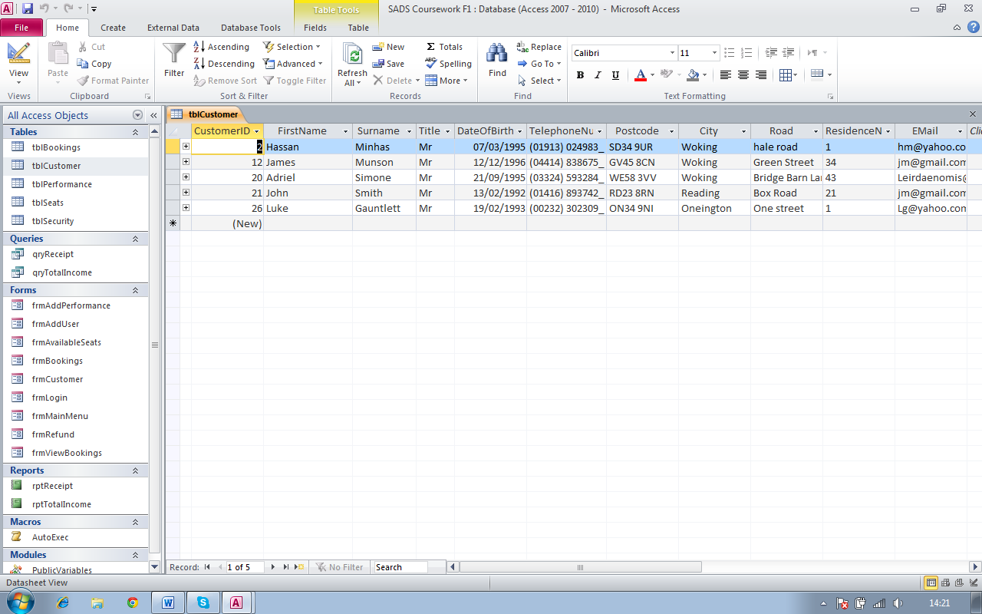

Screenshot 2

Screenshot 1

Here I am showing how many records there are in tblCustomer. This is also showing that tblCustomer stores customer details

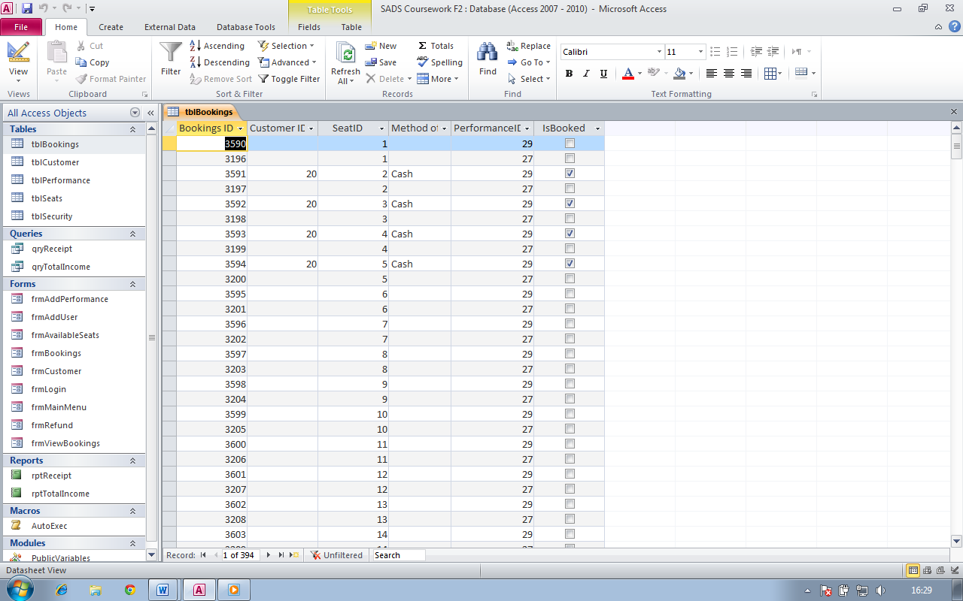

Here I am showing how many records there are in tblBookings. Also this is showing that tblBookings stores bookings. There are 394 records in this table

Screenshot 3

Screenshot 4

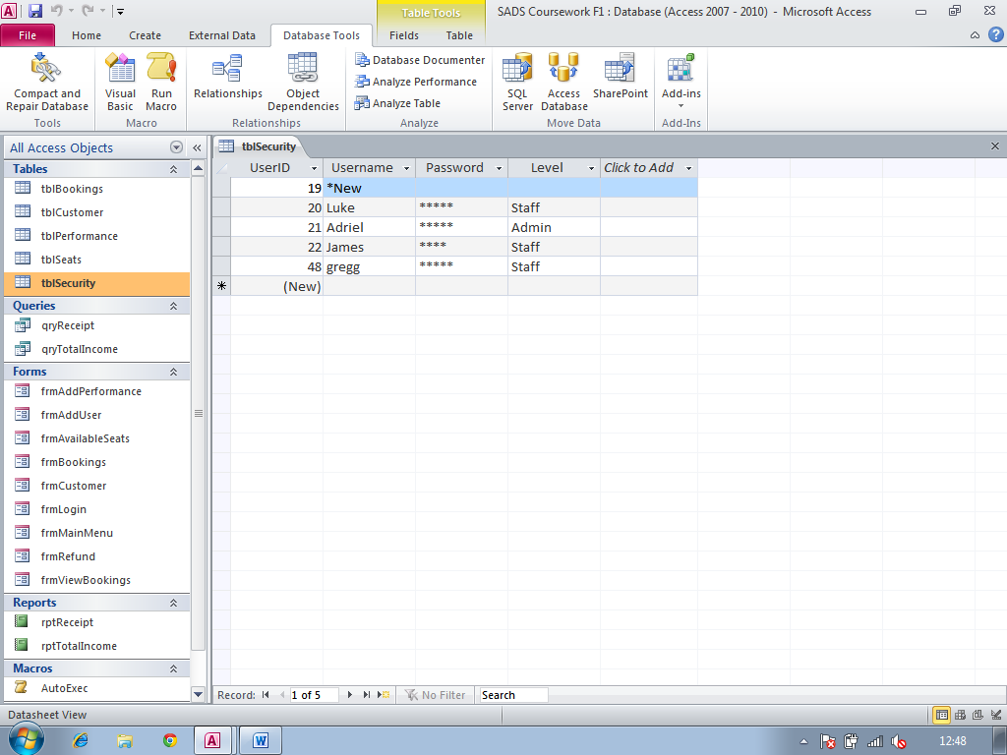



Here I am showing how many records there are in tblSecurity which has 5 records. Also this is showing that tblSecurity holds user details

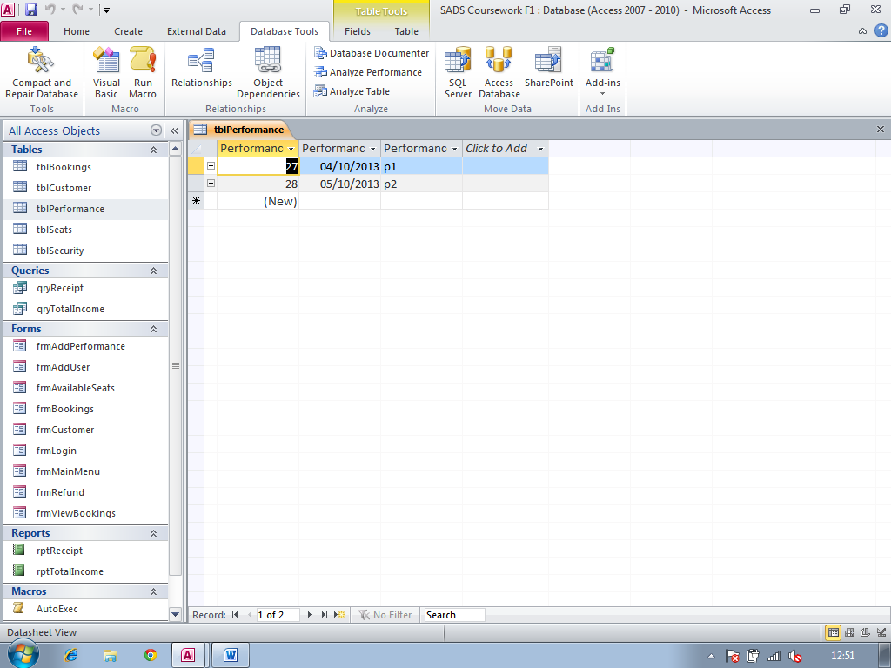



Here I am showing that there are 2 records in tblPerformance. I am also showing that performances are being stored in tblPerformance

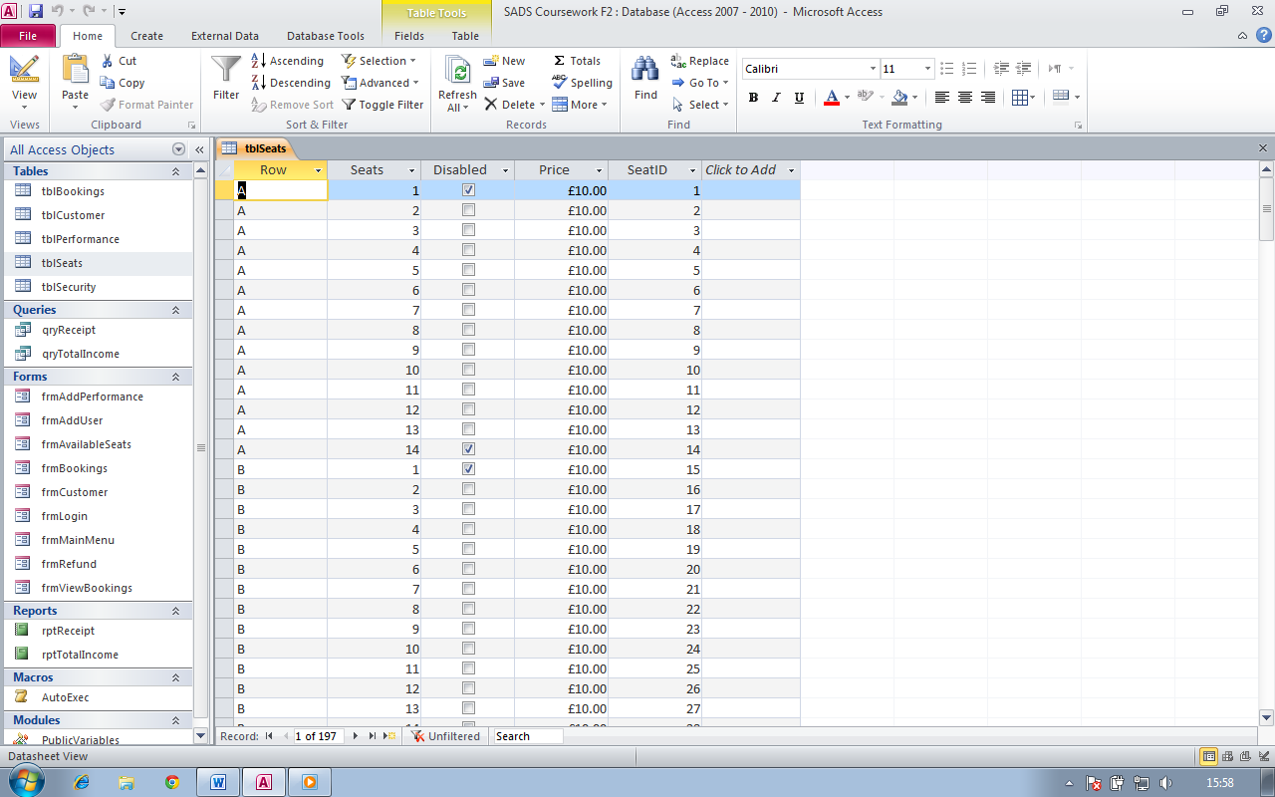

Screenshot 5

Here I am showing that all the seats are stored in tblSeats acting as a reference for the seats in tblBookings. We can also see that there are 197 seats in this table

**Test Numbers:** 16

**Type of test:** Data entry test

**Description:** Adding a new record to tblCustomer using frmCustomer

**Screenshot ref:** 5, 6, 7

Screenshot 5

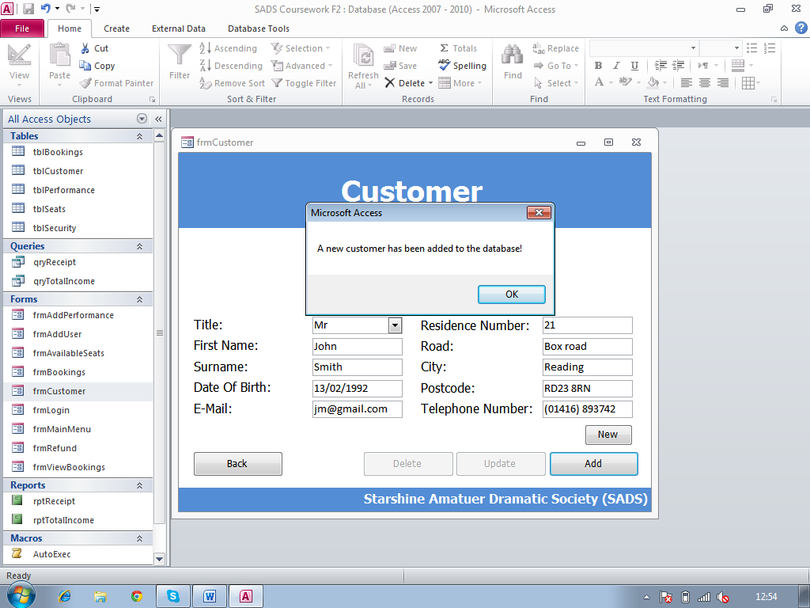

Screenshot 6

Table before new record

Here I have added data to the corresponding text boxes to add a customer in tblCustomer

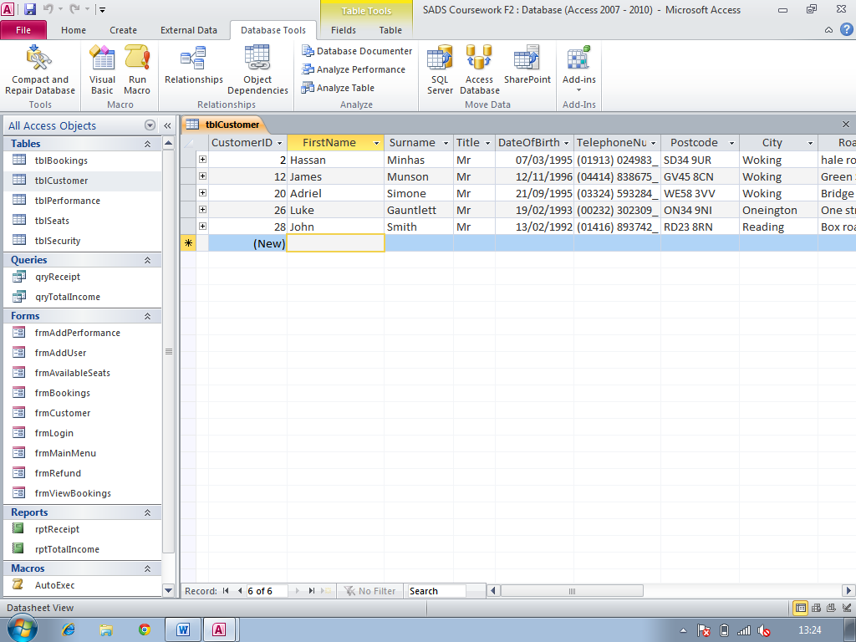

Screenshot 7

Table after record



**Test Number:** 17

**Type of test:** Data entry test

**Description:** Adding a new record to tblPerformance using frmAddPerformance

**Screenshot ref:** 8, 9, 10

Screenshot 8

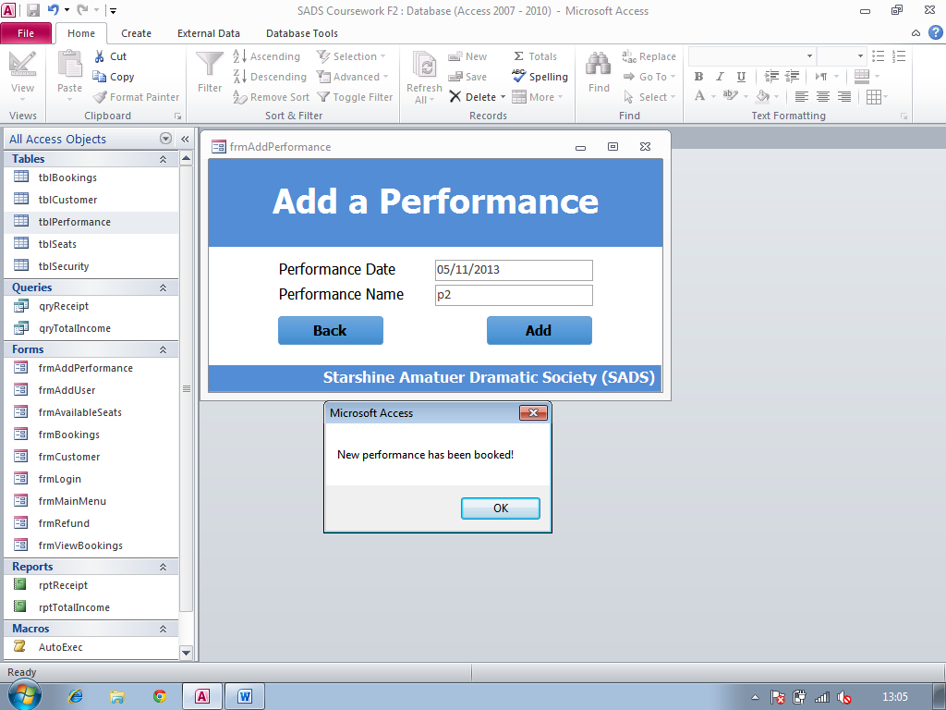

Here I have added data to the corresponding text boxes to add a performance in tblPerformance

Screenshot 9

Table before new record

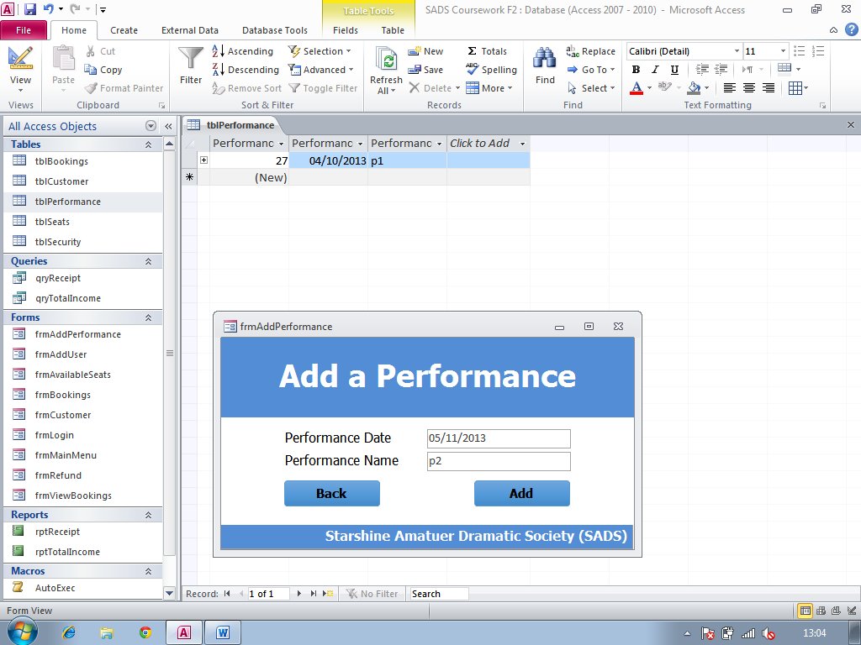

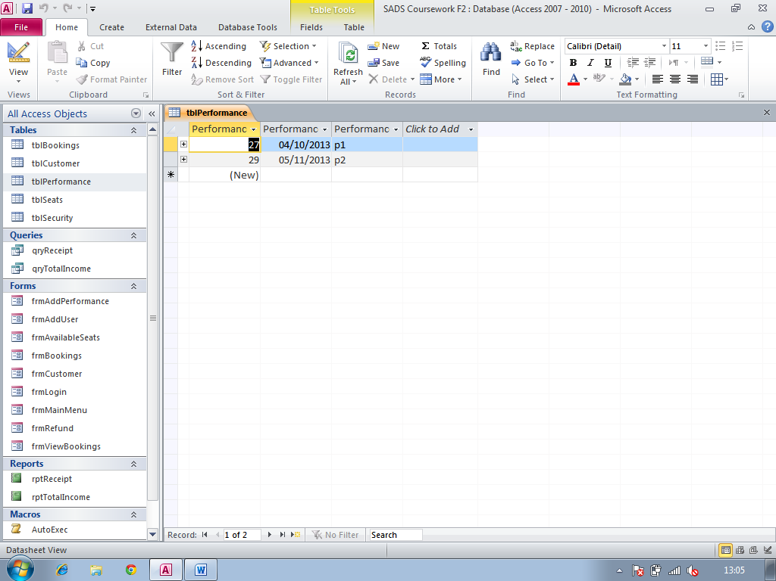

Table after record

Screenshot 10

**Test Number:** 18

**Type of test:** Data entry test

**Description:** Adding a new record to tblUser using frmAddUser

**Screenshot ref:** 11, 12, 13

Screenshot 11

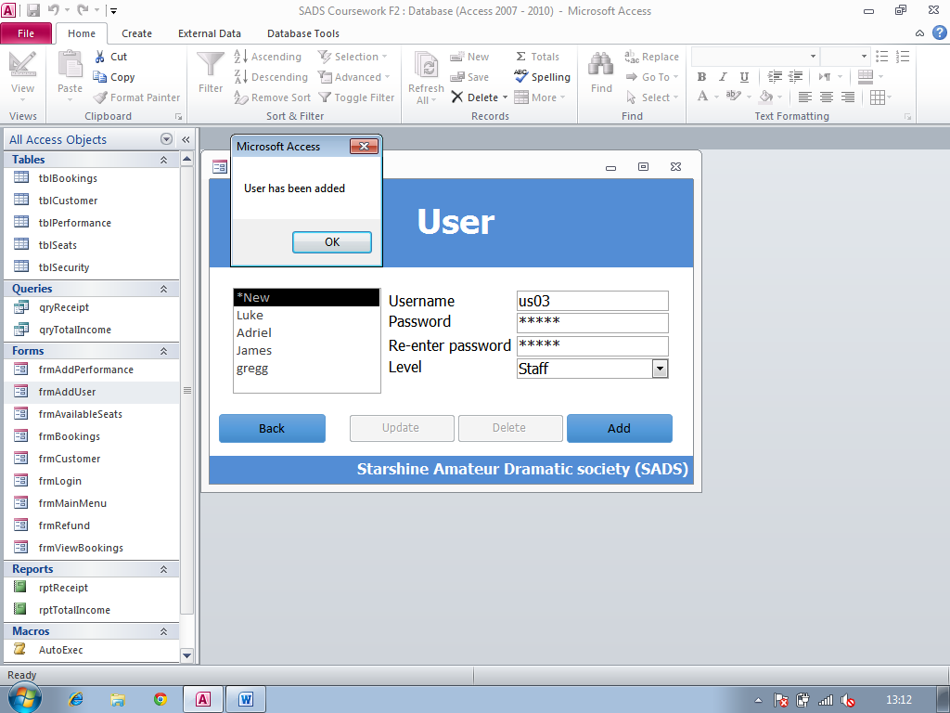

Here I have added data to the corresponding text boxes to add a user in tblSecurity

Table before new record

Screenshot 12

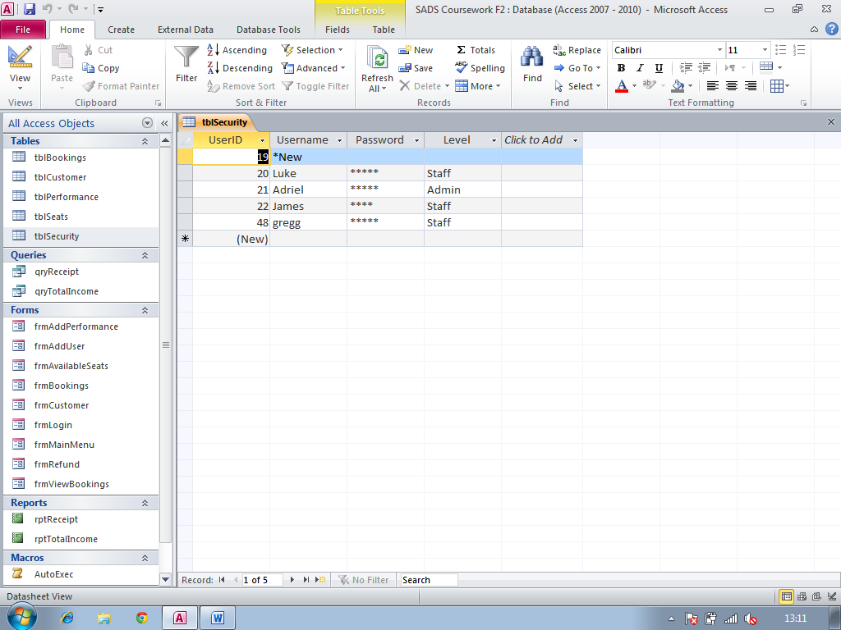

Table after record

Screenshot 13

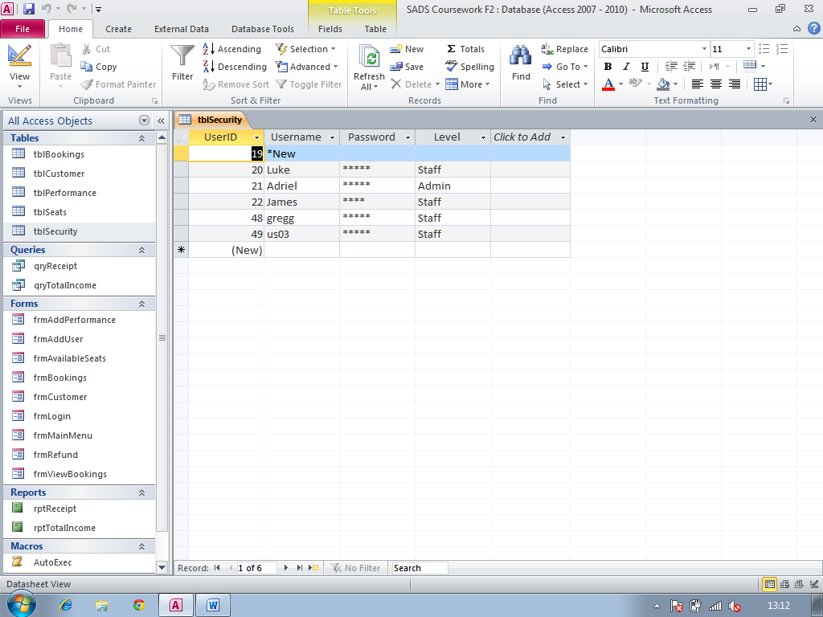

**Test Number:** 19

**Type of test:** Data entry test

**Description:** Adding a new record to tblBookings using frmBookings

**Screenshot ref:** 14, 15, 16

Screenshot 14

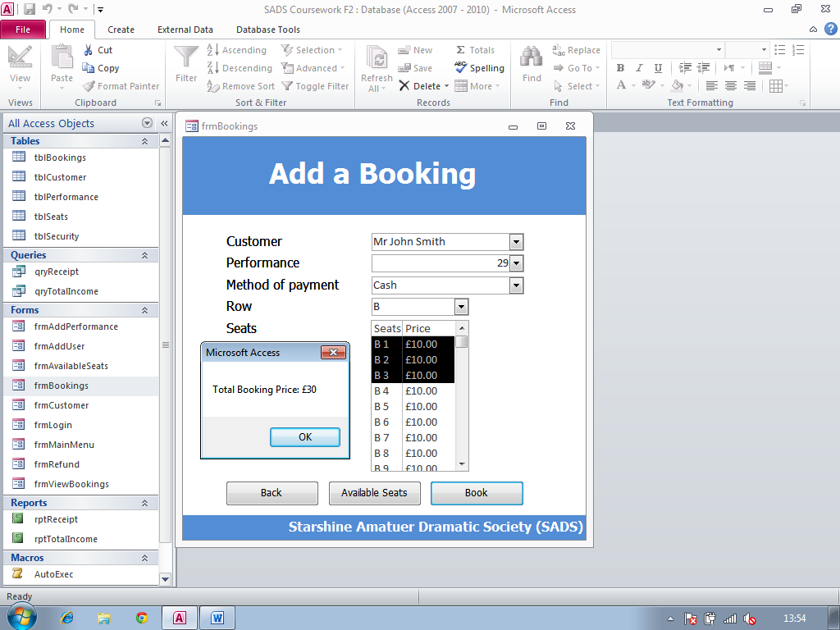

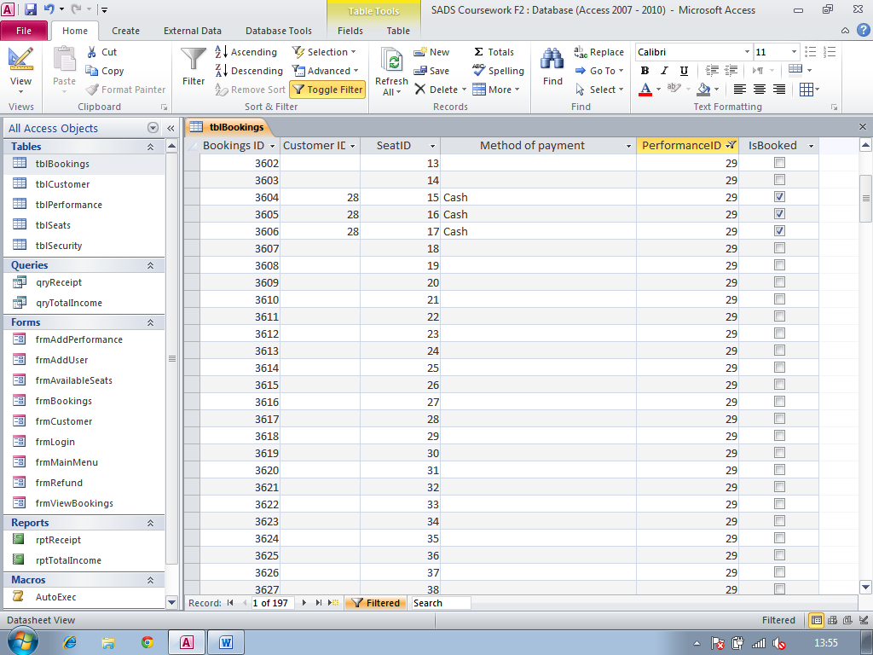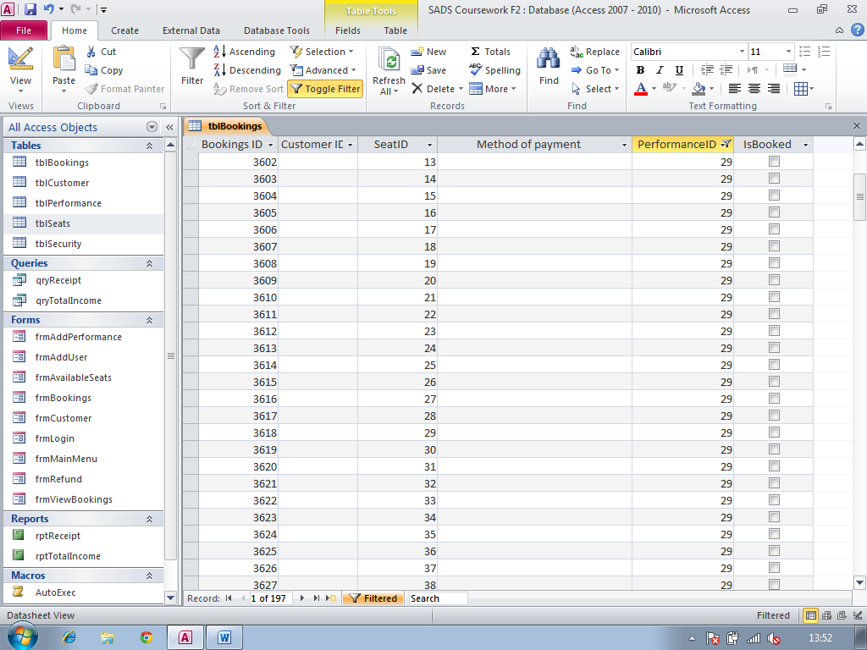

Screenshot 16

Table after record

Screenshot 15

Table before new record

Here I have added data to the corresponding text boxes to add a booking in tblBooking

**Test Number:** 20

**Type of test:** Data edit test

**Description:** editing an existing record to tblCustomer using frmCustomer

**Screenshot ref:** 17, 18, 19

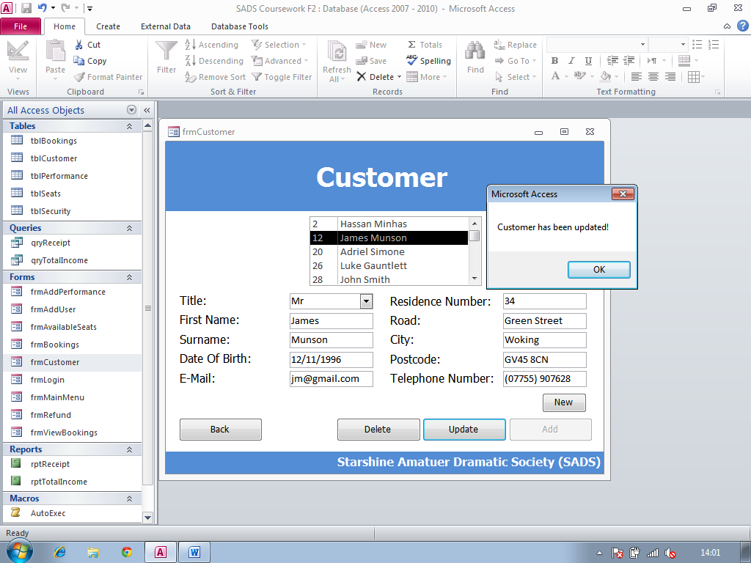

Here I have edited data to the corresponding text boxes to edit a customer in tblCustomer. I have just edited the telephone number field for the selected customer.

Screenshot 17

Screenshot 18

Table before update

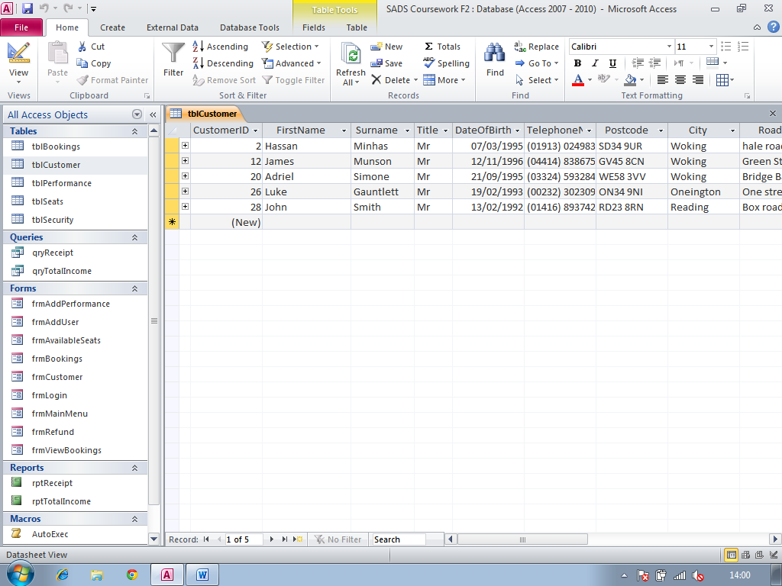

Screenshot 19

Table after update

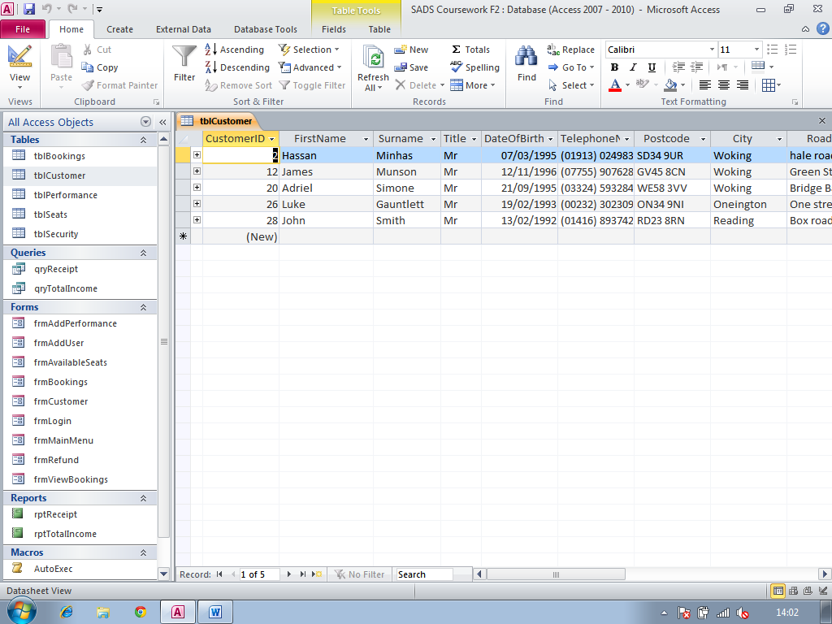

**Test Number:** 21

**Type of test:** Data edit test

**Description:** Editing an existing record to tblUser using frmUser

**Screenshot ref:** 20, 21, 22

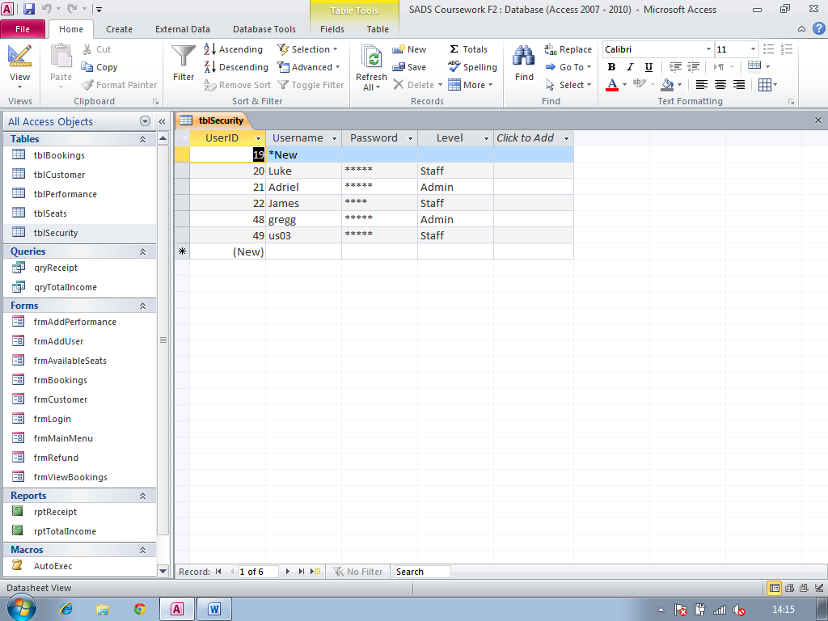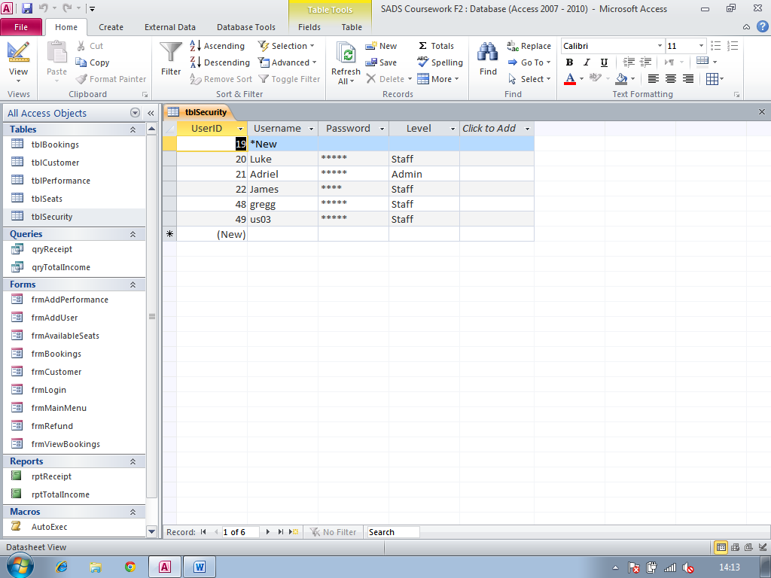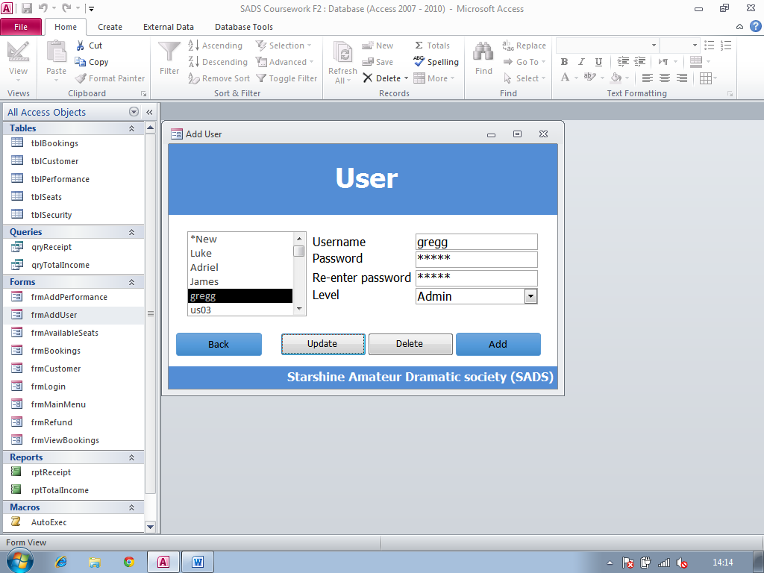

Screenshot 22

Table after update

Screenshot 21

Table before update

Here I have edited data to the corresponding text boxes to edit a user in tblSecurity. I have changed the ‘admin level’ field for the selected user.

Screenshot 20

**Test Number:** 22

**Type of test:** Calculation tests

**Description:** Adding a booking to tblbookings using frmBookings

**Screenshot ref:** 23, 24, 25

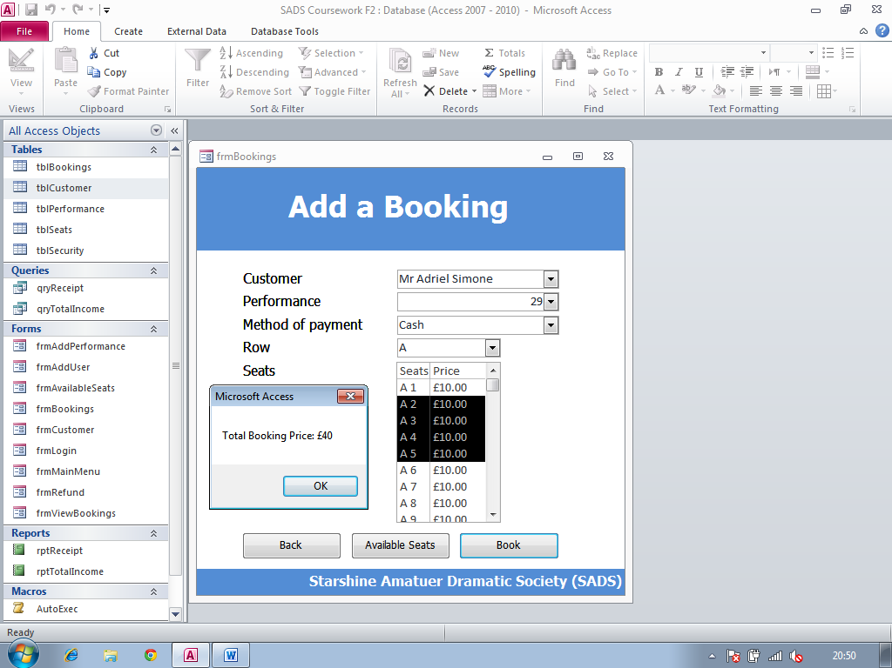

Screenshot 23

Here I have entered data into frmBookings to prove test number 22. As you can see the total booking price is £40.00 which is exactly what I expected it to be.

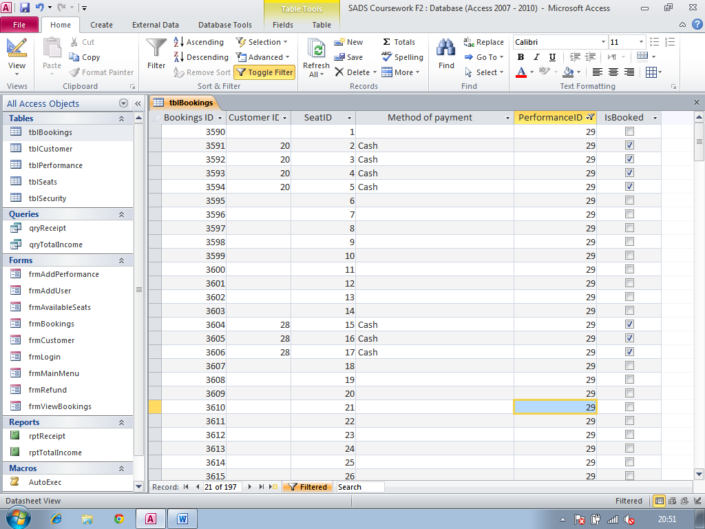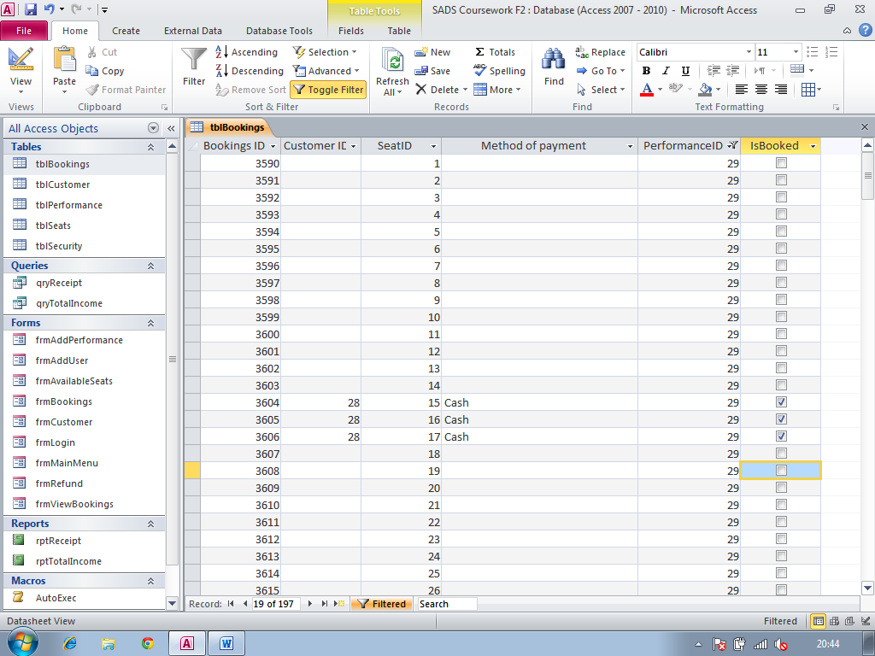

Screenshot 25

Table after update

Screenshot 24

Table before update

**Test Number:** 23

**Type of test:** Calculation tests

**Description:** Adding a booking to tblbookings using frmBookings

**Screenshot ref:** 26, 27, 28

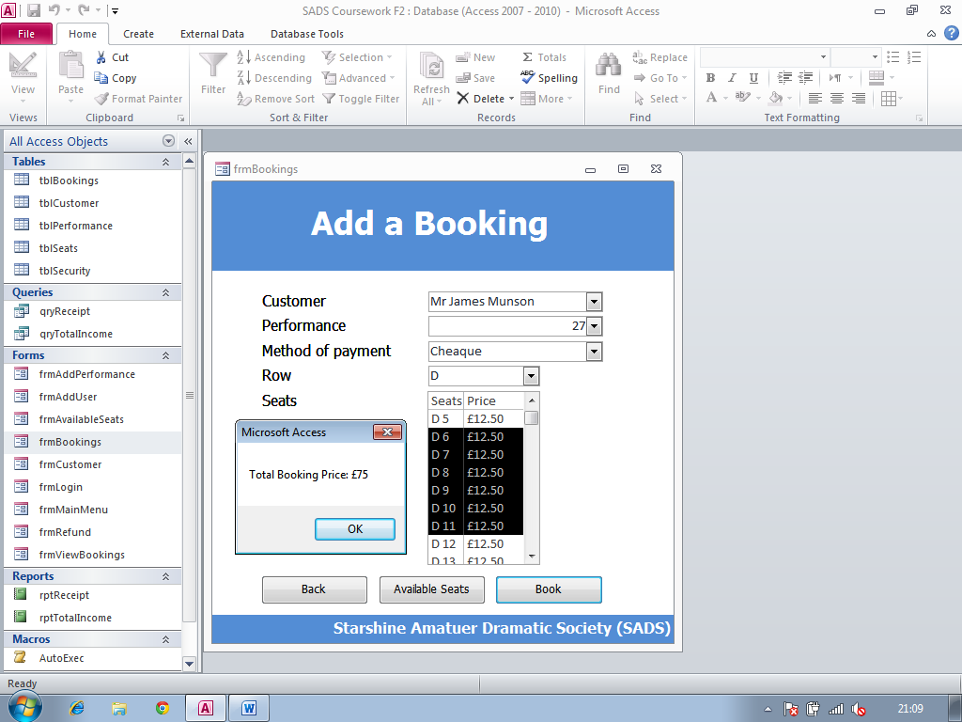

Screenshot 26

Here I have entered data into frmBookings to prove test number 23. As you can see the total booking price is £75.00 which is exactly what I expected it to be.

Screenshot 27

Table before update

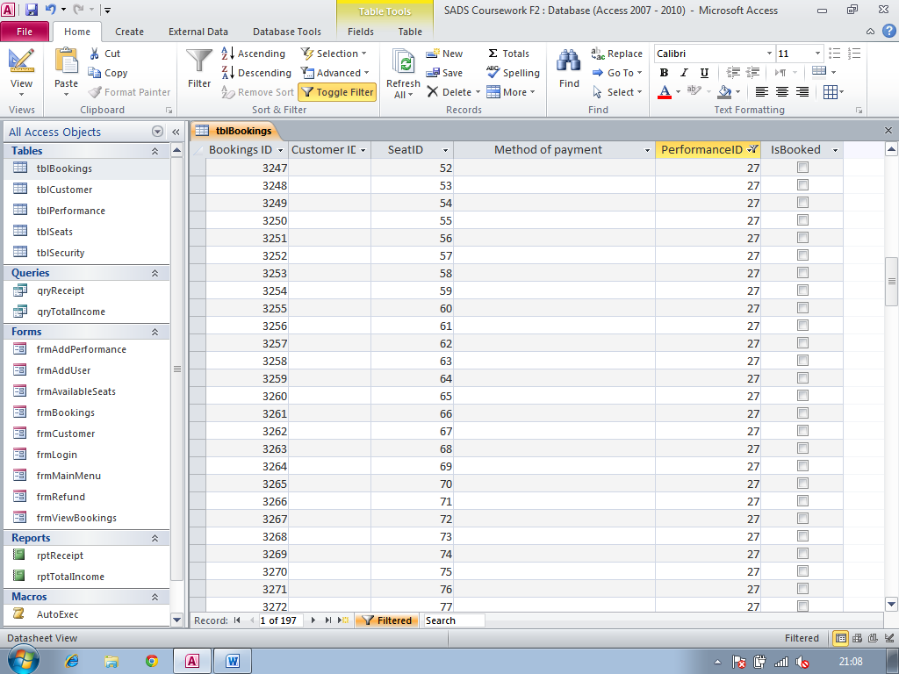

Screenshot 28

Table after update

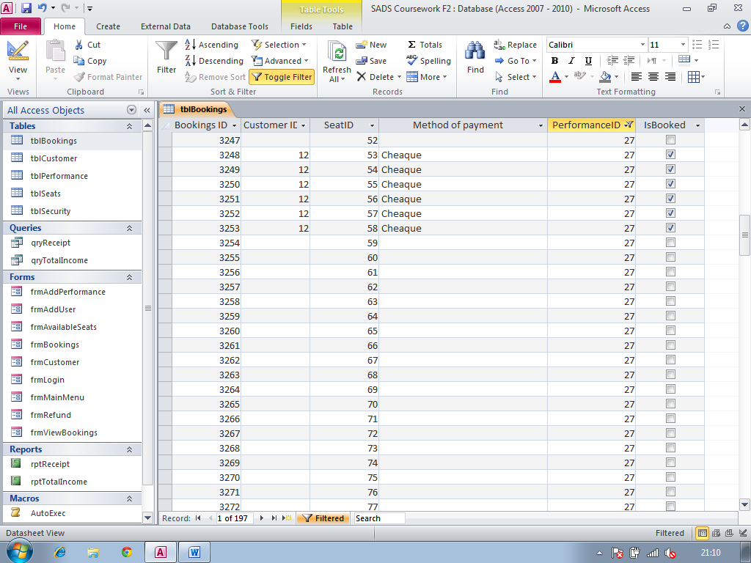

**Test Number:** 24

**Type of test:** Calculation tests

**Description:** Adding a booking to tblbookings using frmBookings

**Screenshot ref:** 29, 30, 31

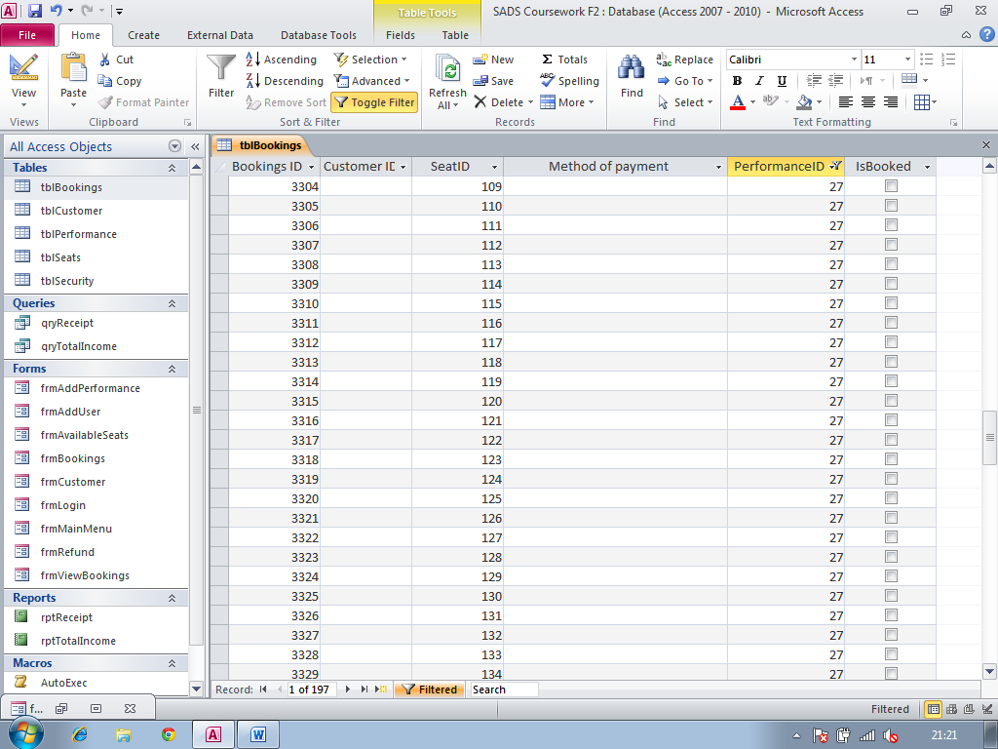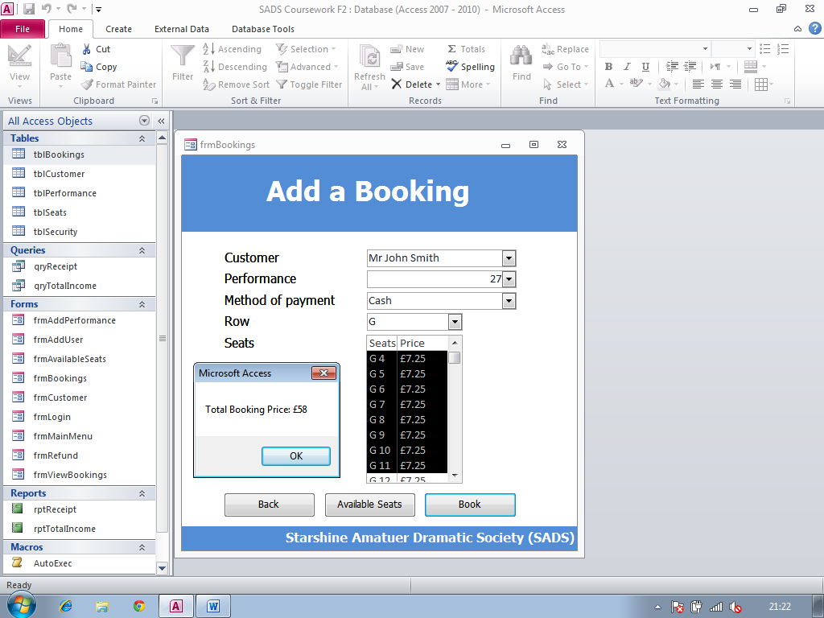

Screenshot 30

Table before update

Here I have entered data into frmBookings to prove test number 24. As you can see the total booking price is £58.00 which is exactly what I expected it to be.

Screenshot 29

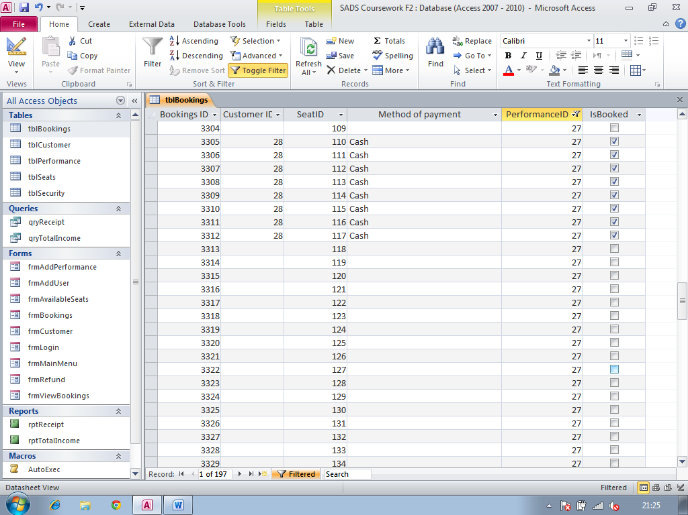

Screenshot 31

Table after update

**Test Number:** 25

**Type of test:** Calculation tests

**Description:** Adding a booking to tblbookings using frmBookings

**Screenshot ref:** 32, 33, 34

Screenshot 32

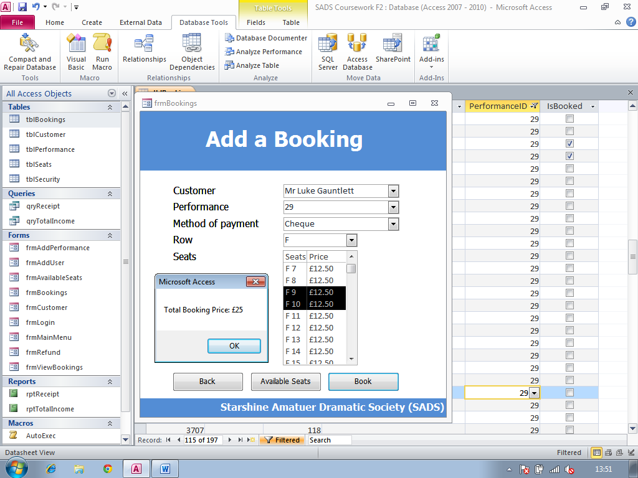

Here I have entered data into frmBookings to prove test number 25. As you can see the total booking price is £25.00 which is exactly what I expected it to be.

Screenshot 33

Table before update

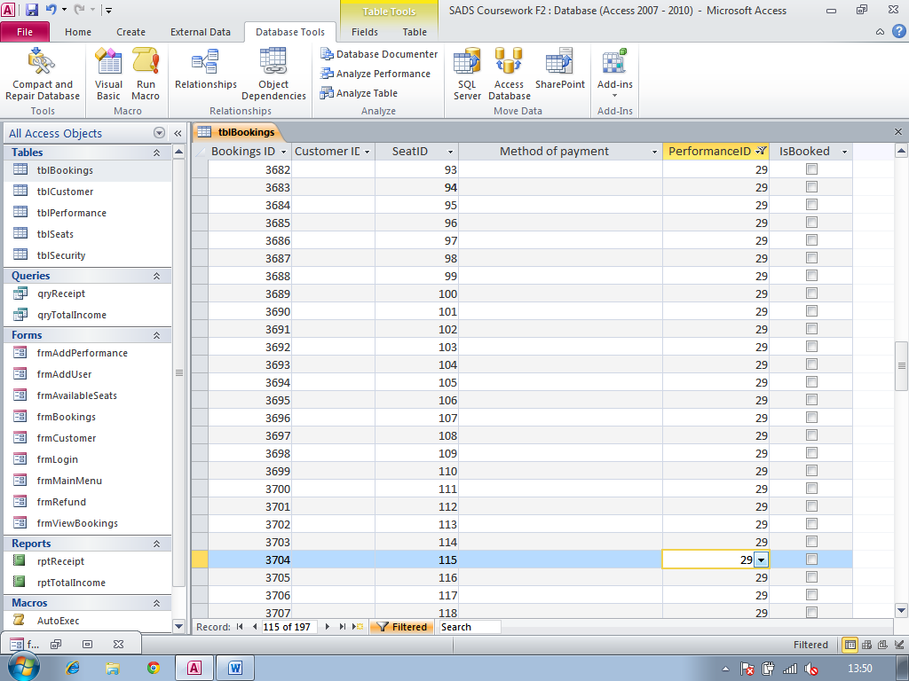

Screenshot 34

Table after update

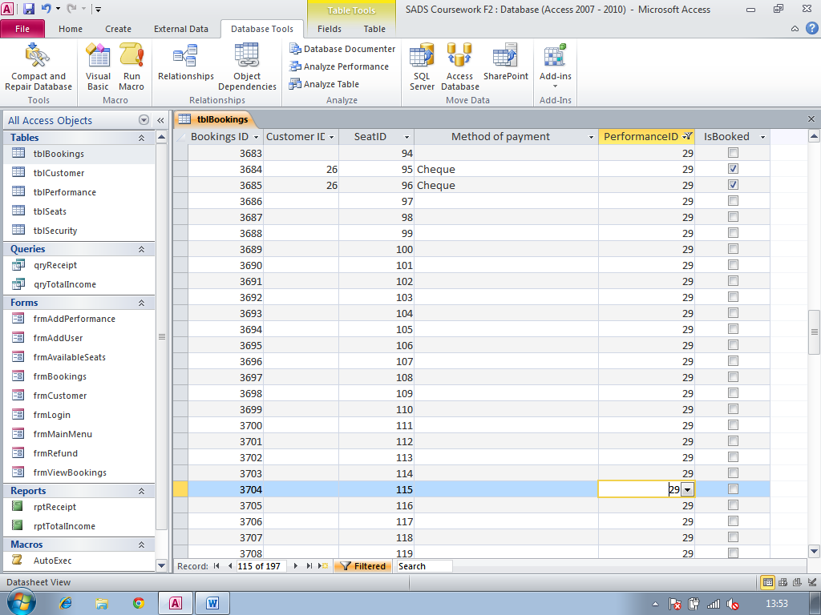

**Test Number:** 26

**Type of test:** Calculation tests

**Description:** Deleting a booking in tblBookings using frmRefund

**Screenshot ref:** 35, 36, 37

Screenshot 35

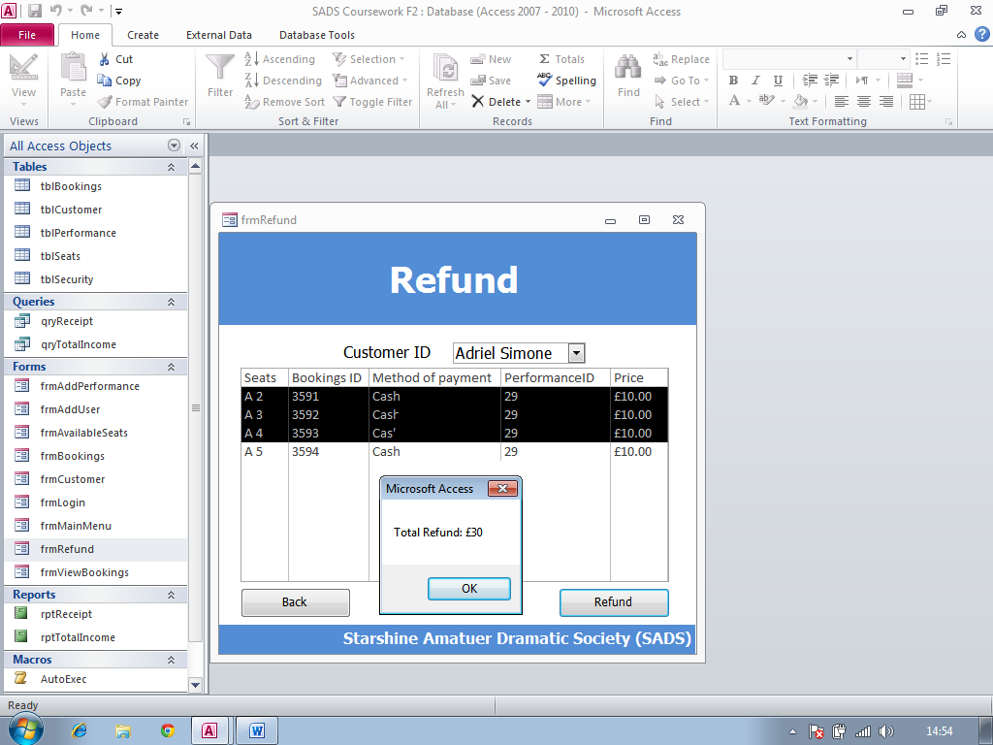

Here I have selected data in frmRefund to prove test number 26. As you can see the total refund price is £30.00 which is exactly what I expected it to be.

Screenshot 36

Table before update



Screenshot 37

Table after update

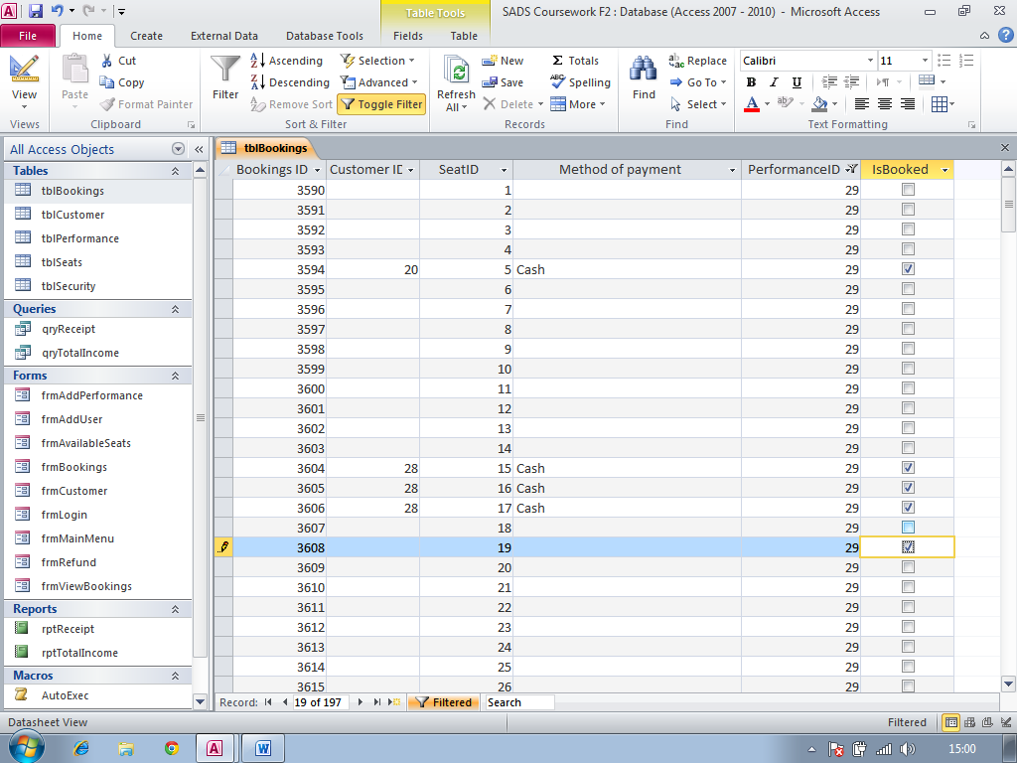

**Test Number:** 27

**Type of test:** Calculation tests

**Description:** Deleting a booking in tblBookings using frmRefund

**Screenshot ref:** 38, 39, 40

Screenshot 38

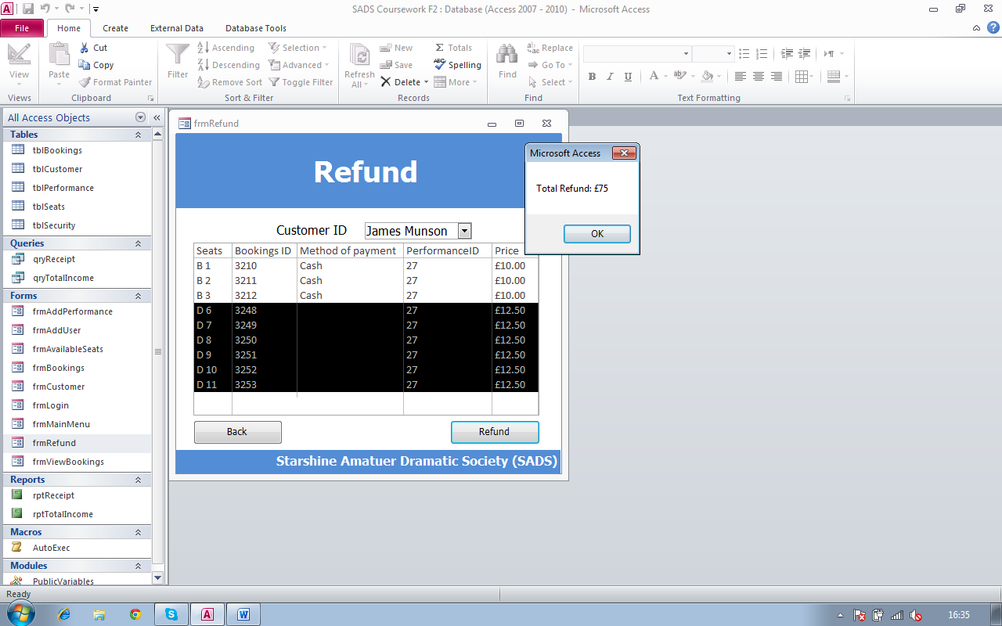

Here I have selected data in frmRefund to prove test number 27. As you can see the total refund price is £75.00 which is exactly what I expected it to be.

Screenshot 39

Table before update



Screenshot 40

Table after update

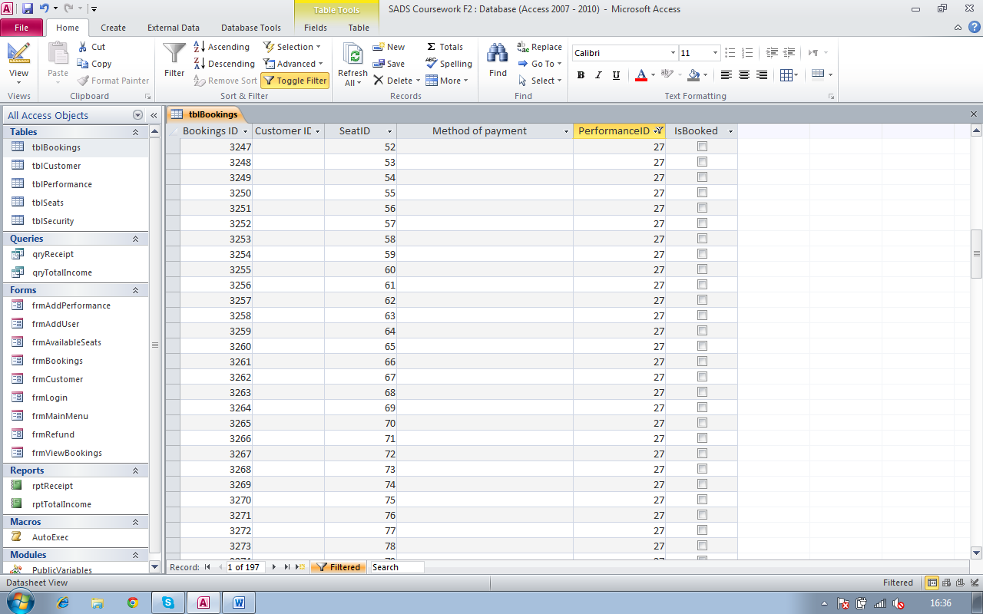

**Test Numbers:** 28 - 31

**Type of test:** Calculation tests

**Description:** booking conformation

**Screenshot ref:** 41, 42, 43, 44

Screenshot 41

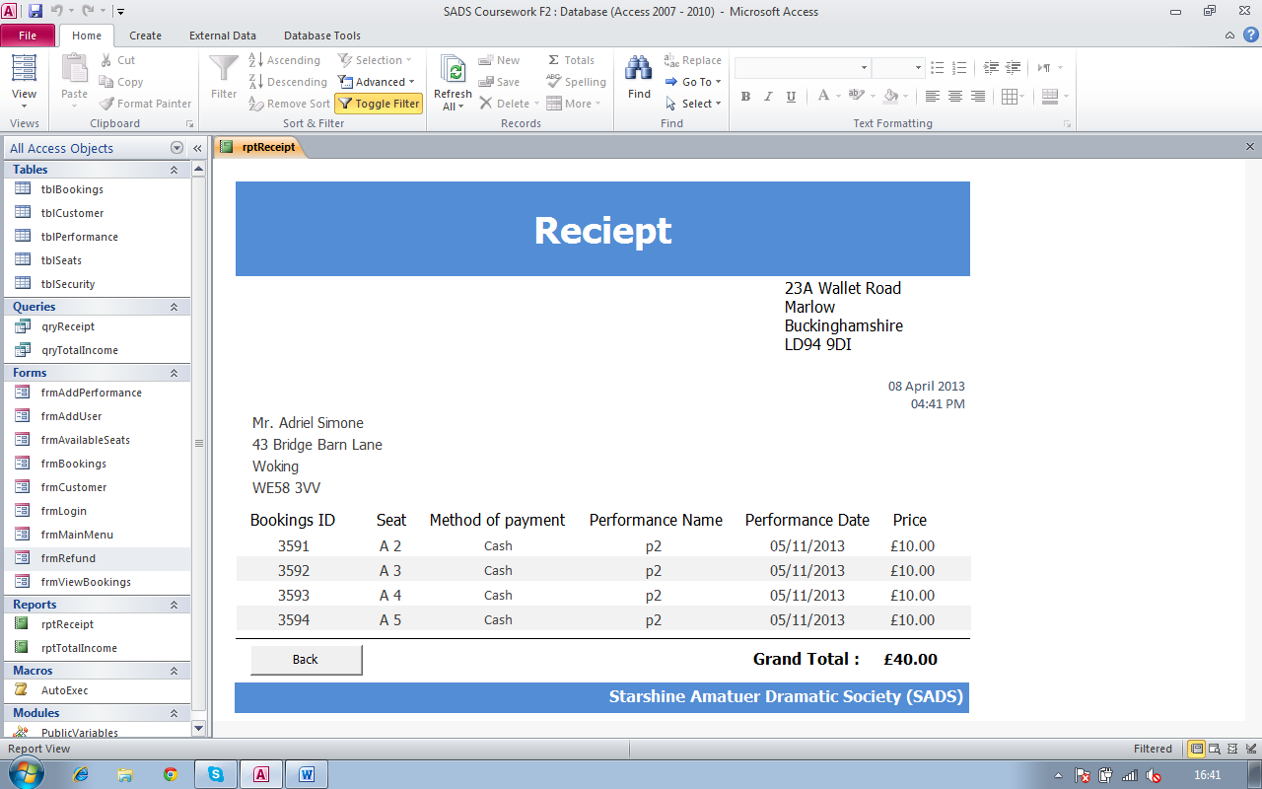

Here is the receipt for the booking made in test number 22

Screenshot 42

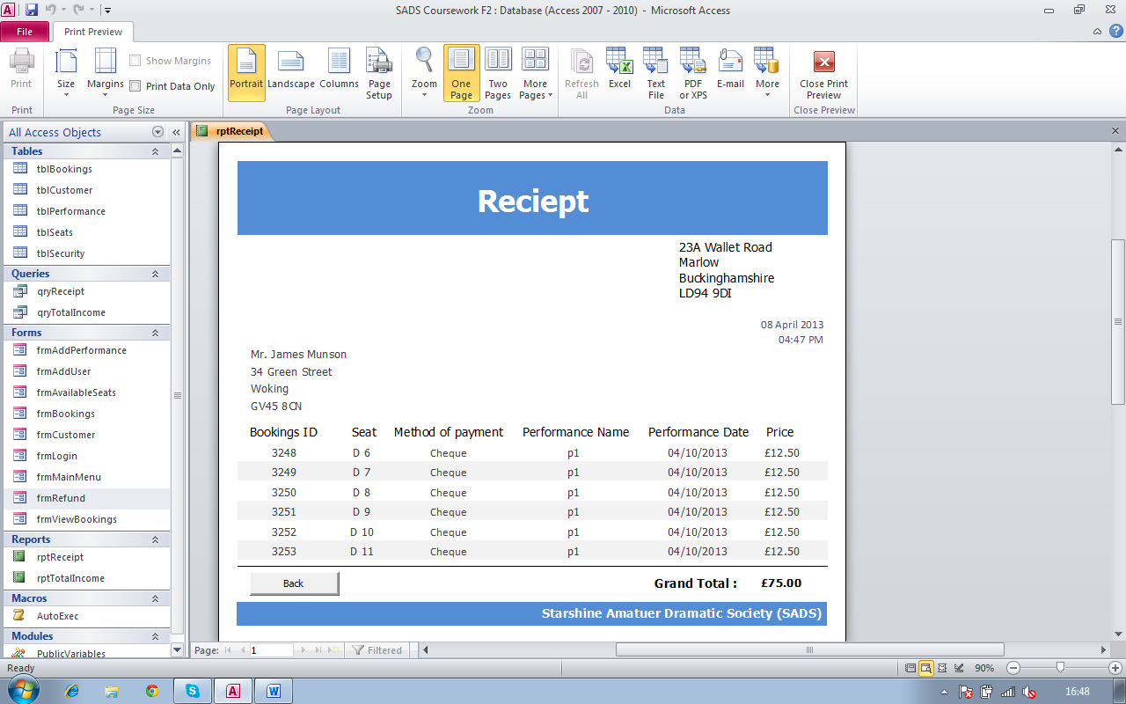

Here is the receipt for the booking made in test number 23

Screenshot 43

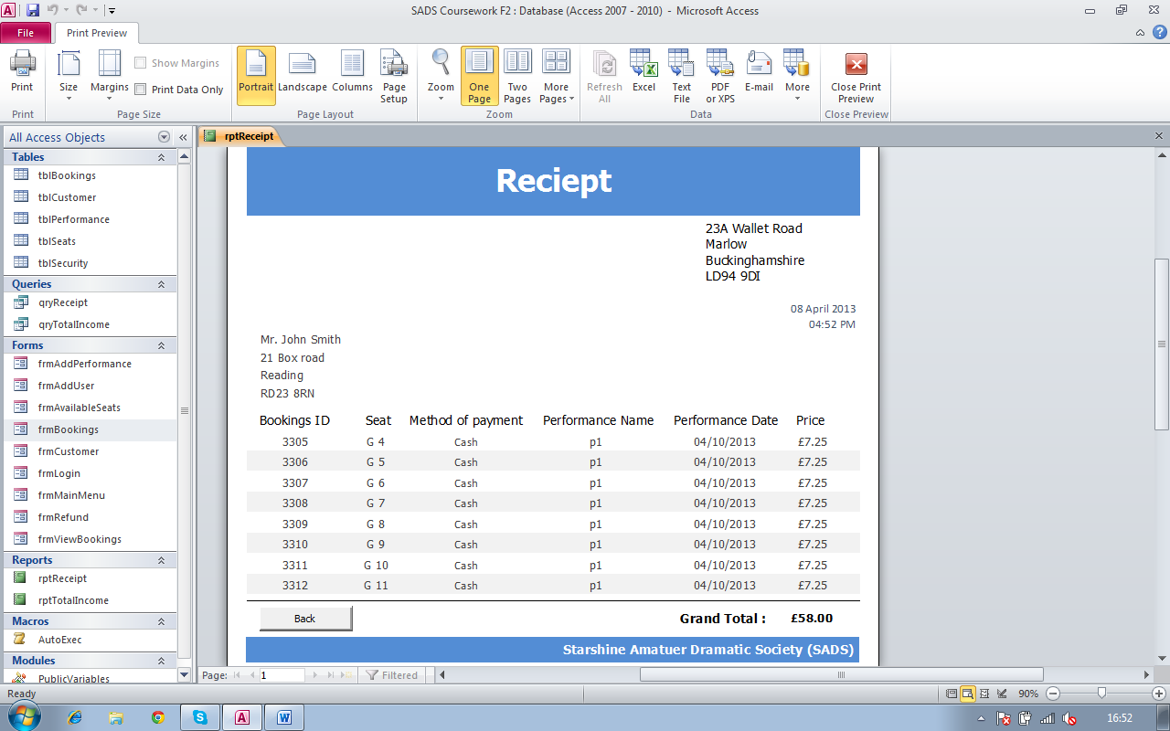

Here is the receipt for the booking made in test number 24

Screenshot 44

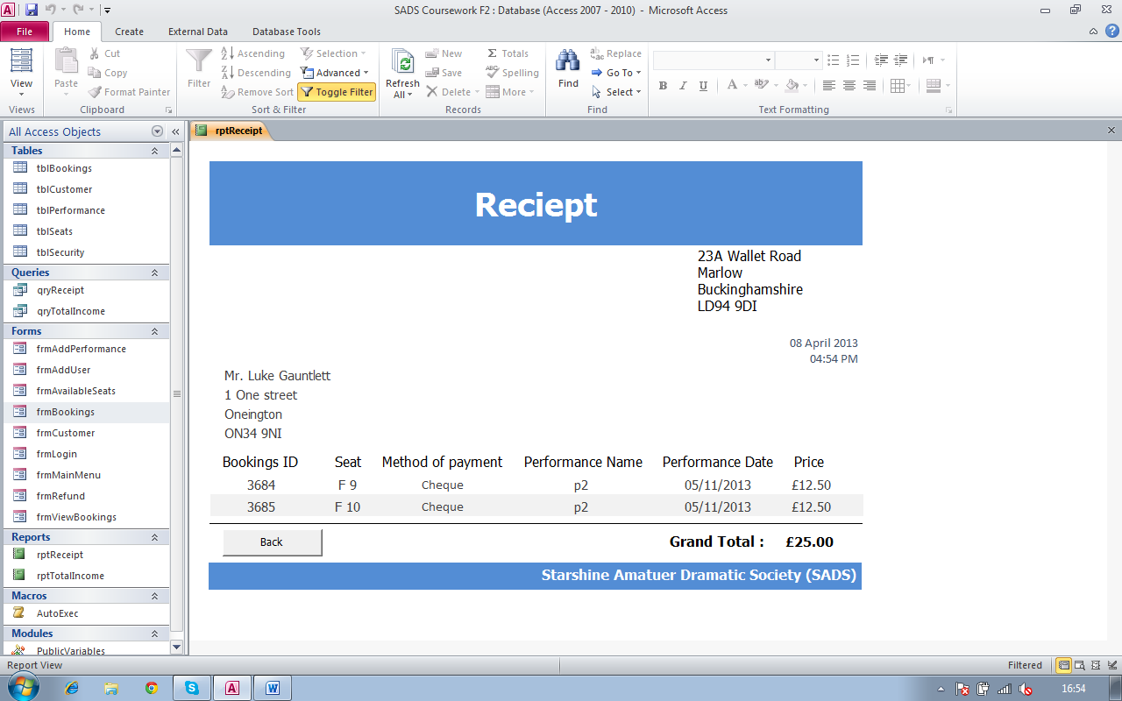

Here is the receipt for the booking made in test number 25

**Test Number:** 32 - 33

**Type of test:** Calculation tests

**Description:** Total Income

**Screenshot ref:** 45

Screenshot 45

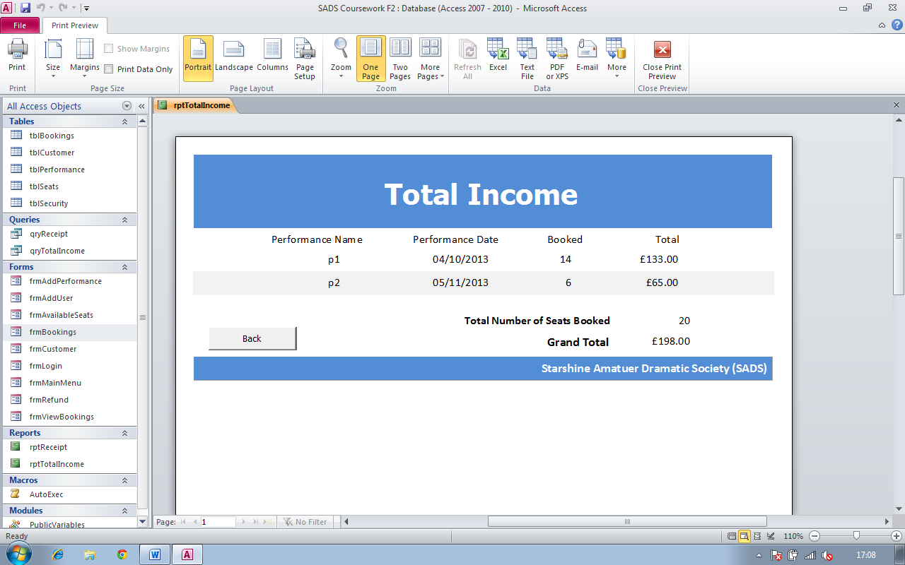

Here is the total income report and all the values are exactly what I expected it to be thus I can conclude that this report functions as it should do.

**Test Number:** 34

**Type of test:** Boundary tests

**Description:** Shows how date in future can only be valid (date this screenshot was taken at 13/04/2013)

**Screenshot ref:** 46, 47, 48

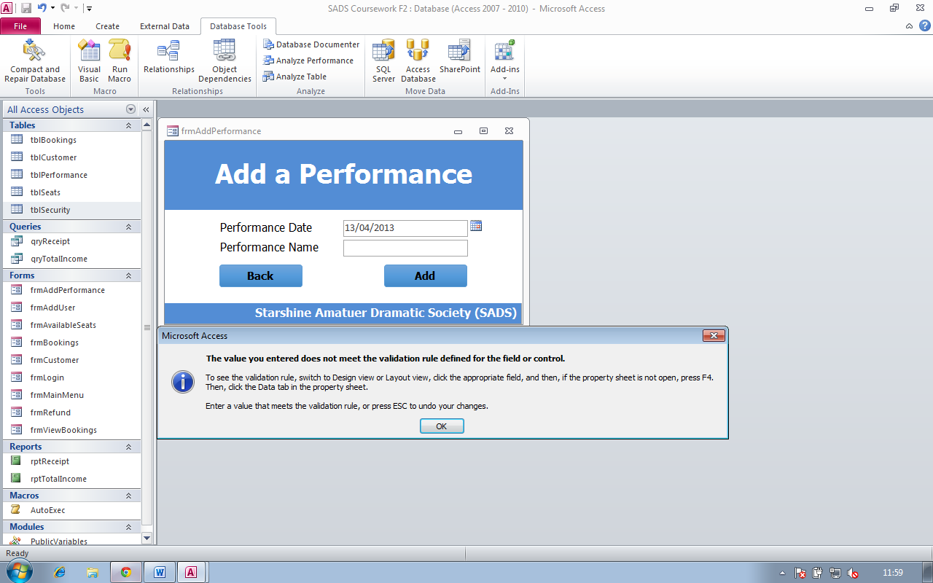

Here I am showing that an error message appears if I select the current date because I wouldn’t make any sense to have a performance on the date it was open for bookings

Screenshot 46

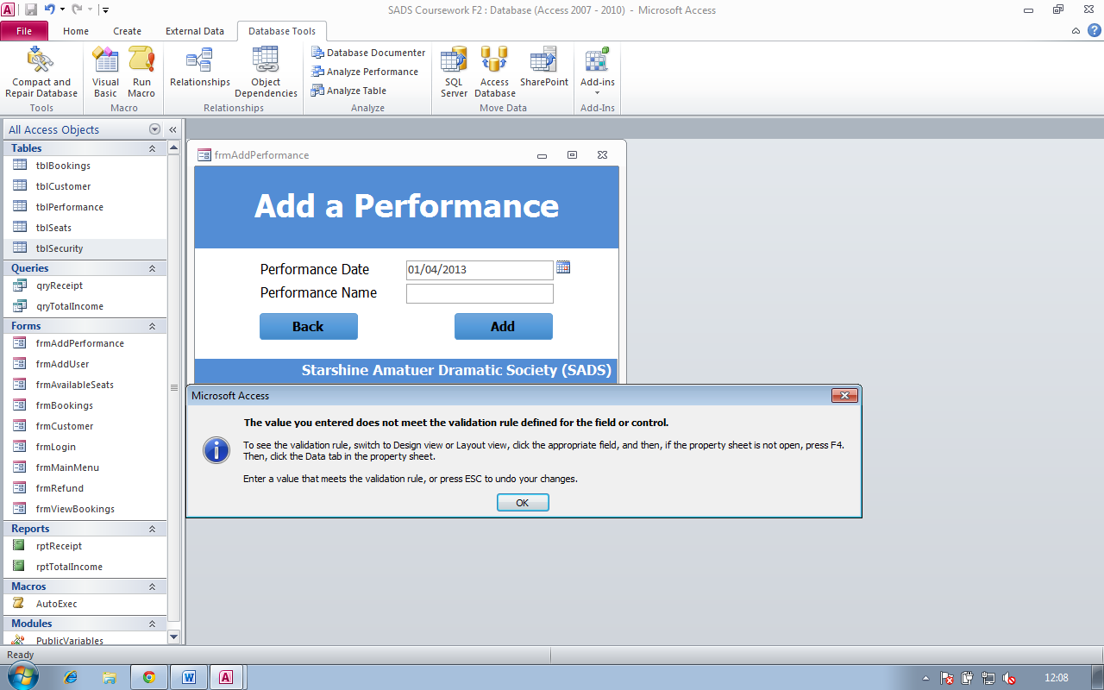

Screenshot 47

Above I am showing that a date in the past in not a valid date because you wouldn’t want to book a performance which has already been performed.

Screenshot 48

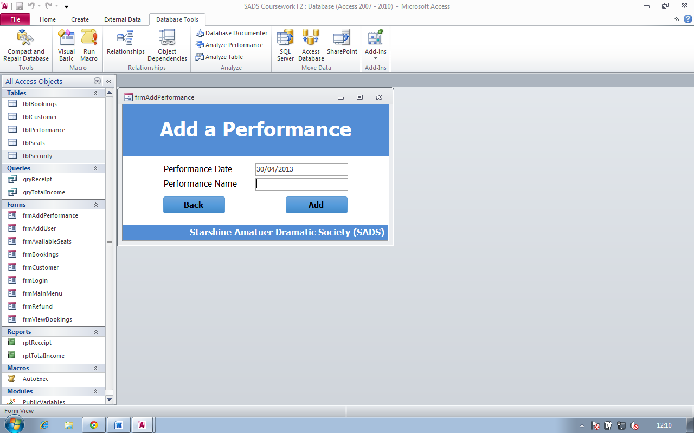

A date in the future is valid hence no error messages appear

**Test Number:** 35

**Type of test:** Boundary Tests **Description:** Shows how date in past can only be selected for the date of birth field on frmCustomer (Date at this was taken at: 14/04/13). **Screenshot ref:** 49. 50, 51

Screenshot 49

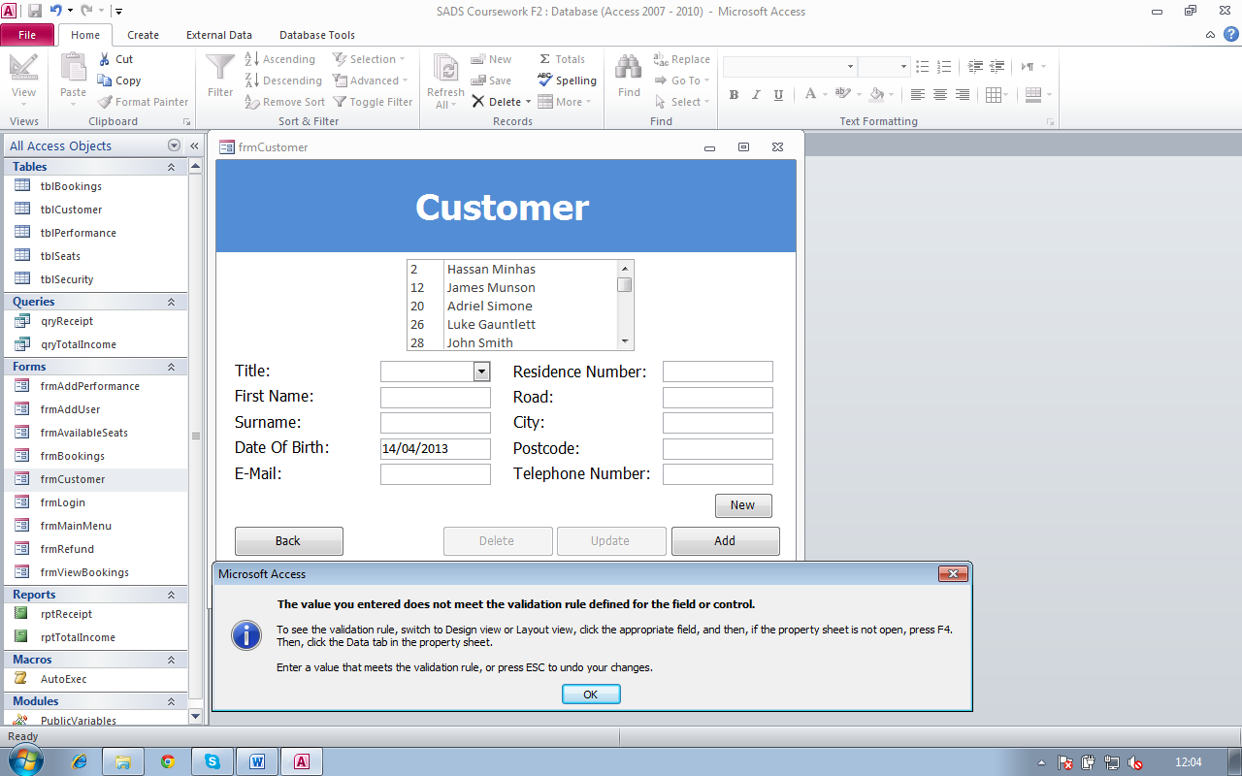

Here I am showing that an error message appears if I select the current date because I wouldn’t make any sense to have a person who’s just been born to be a customer

Screenshot 50

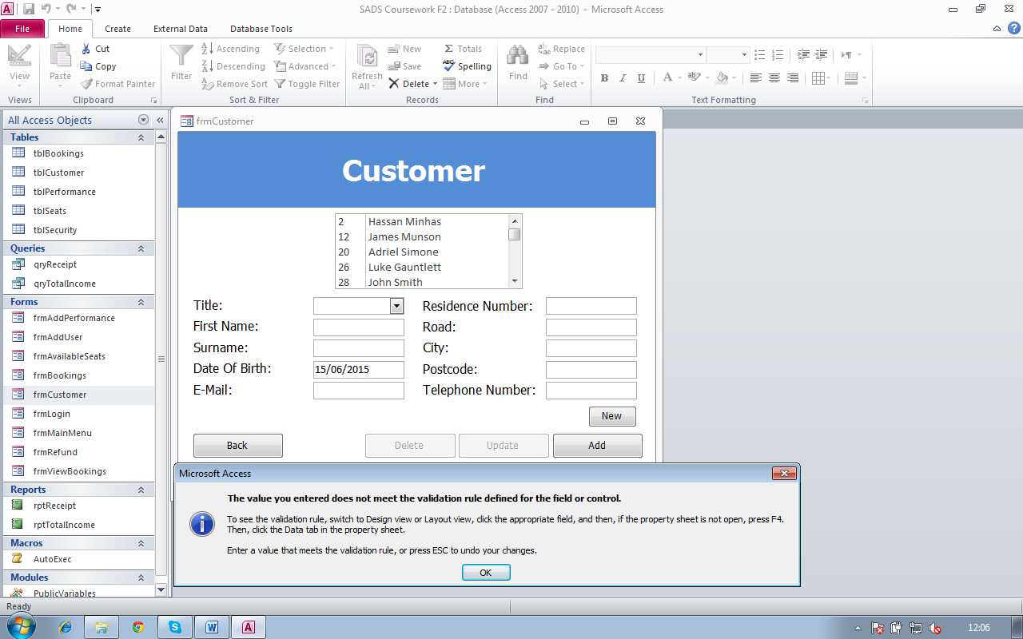

Here I am showing that a date in the future in not a valid date because you can’t be a customer if u haven’t been born yet.

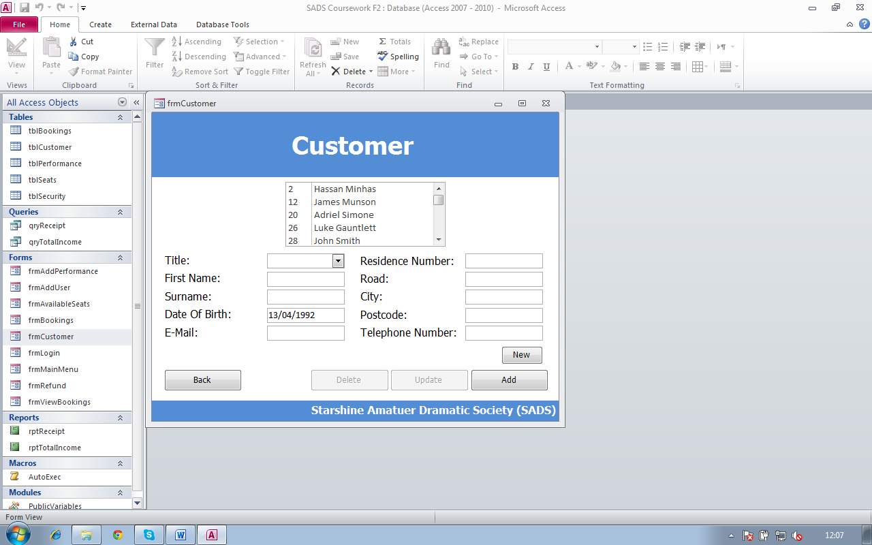

Screenshot 51

A date in the past is valid hence no error messages appear

**Test Number:** 36

**Type of test:** erroneous data test

**Description:** frmCustomer

**Screenshot ref:** 52, 53, 54, 55, 56, 57, 58, 59, 60, 61

Screenshot 52

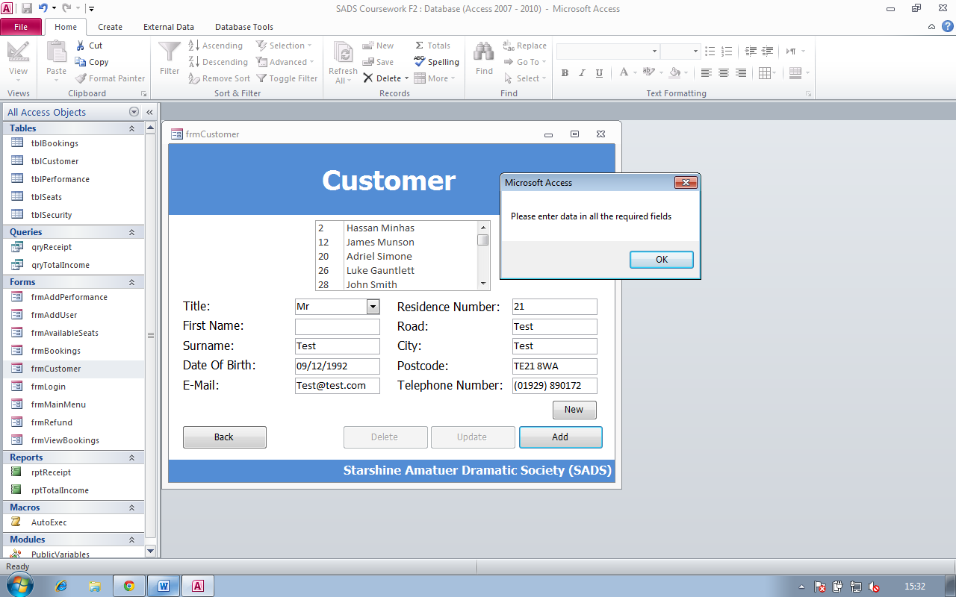

Here I have missed out the ‘first name’ field to show that it is required, as an error message appears if a user would miss out the ‘first name’ field

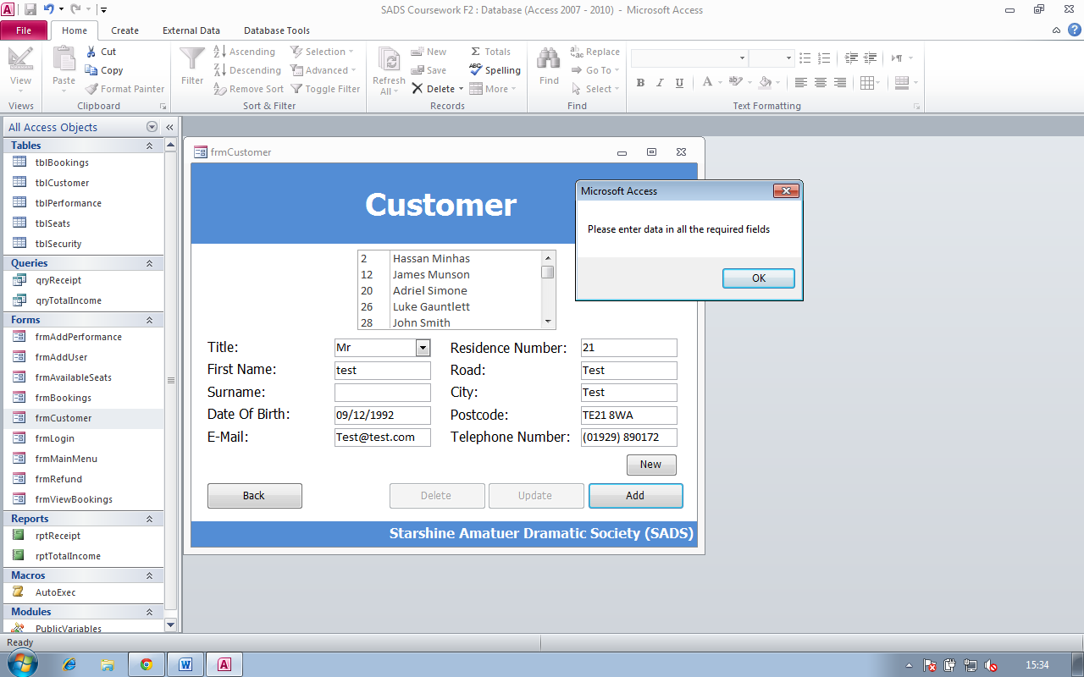

Screenshot 53

Here I have missed out the ‘surname’ field to show that it is required, as an error message appears if a user would miss out the ‘surname’ field

Screenshot 54

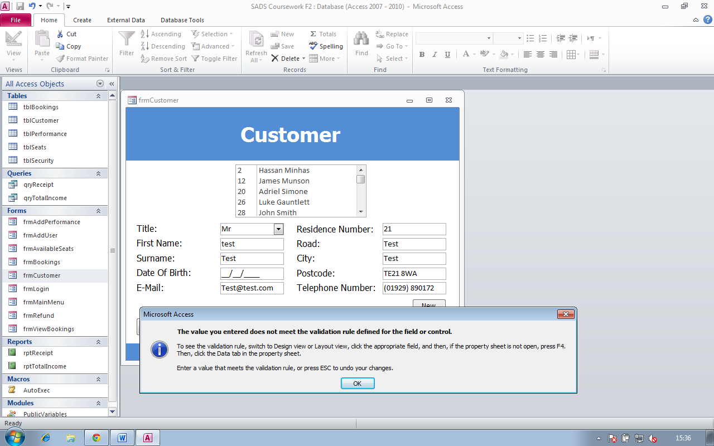

Here I have missed out the ‘date of birth’ field to show that it is required, but a different error message appeared which was not expected but it came because of the validation rule on the ‘date of birth’ field which meant that I wasn’t meeting the validation rule. However if there wasn’t any validation rule then an error message would appear asking the user to fill in all the fields as before

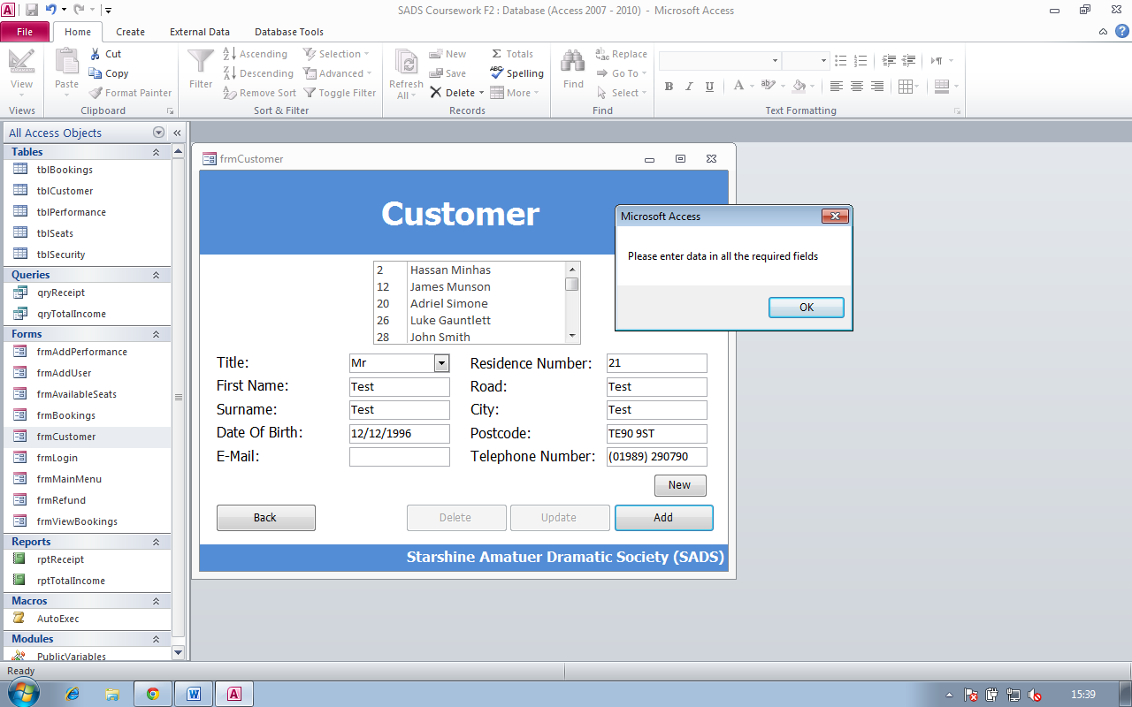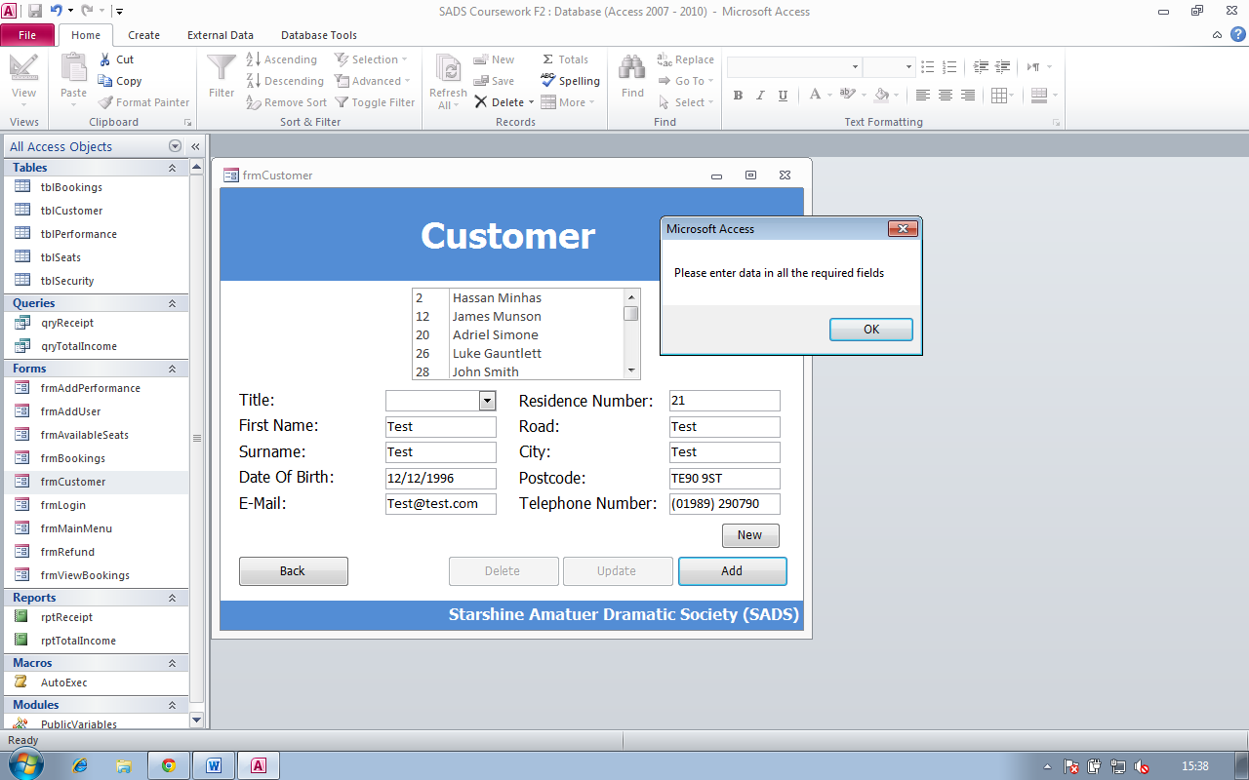

Here I have missed out the ‘email’ field to show that it is required, as an error message appears if a user would miss out the ‘email’ field

Screenshot 56

Here I have missed out the ‘title’ field to show that it is required, as an error message appears if a user would miss out the ‘title’ field

Screenshot 55

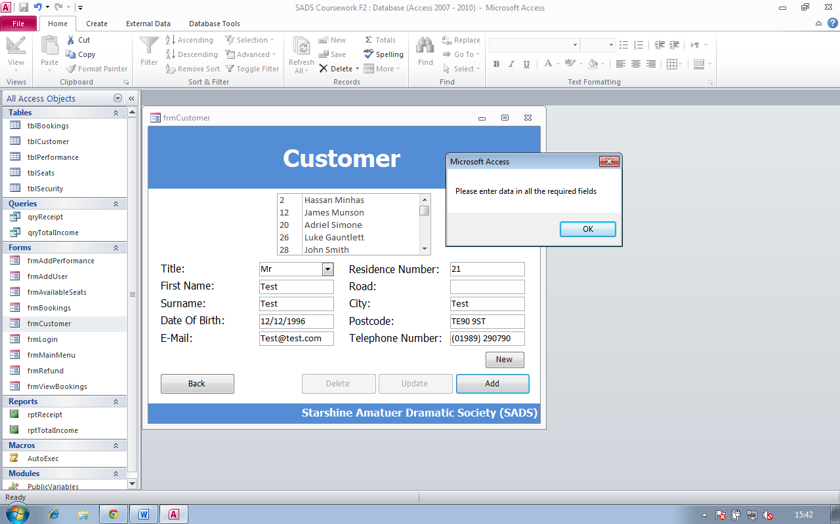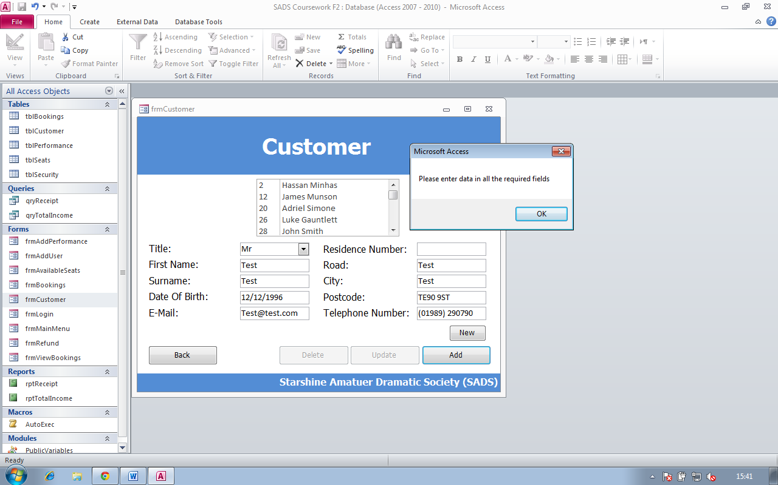

Here I have missed out the ‘Road’ field to show that it is required, as an error message appears if a user would miss out the ‘Road’ field

Screenshot 58

Here I have missed out the ‘Residence Number’ field to show that it is required, as an error message appears if a user would miss out the ‘Residence number’ field

Screenshot 57

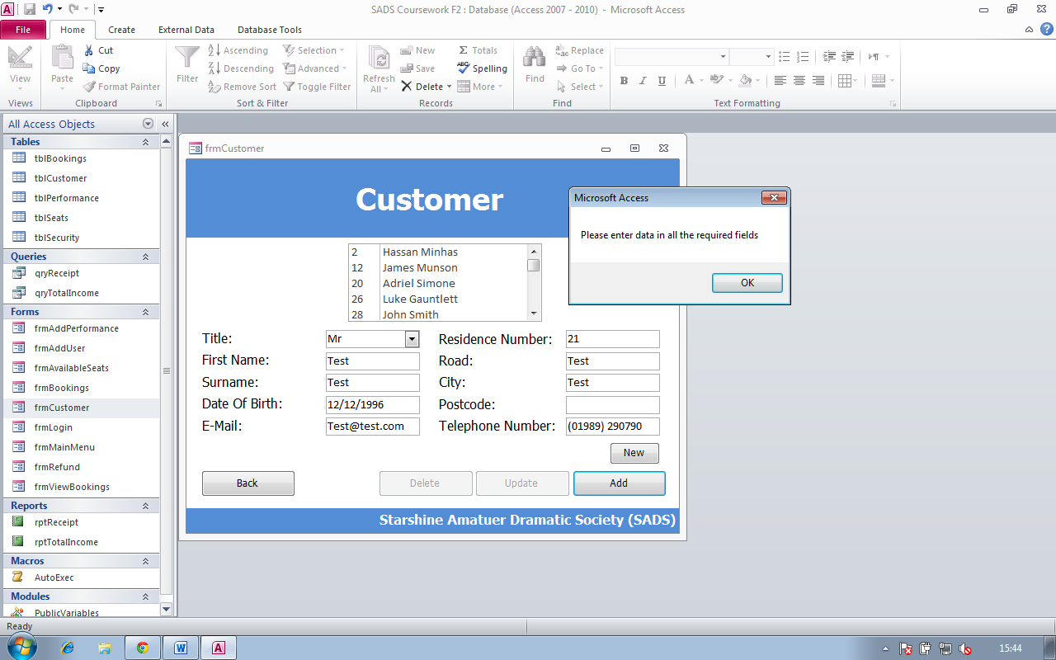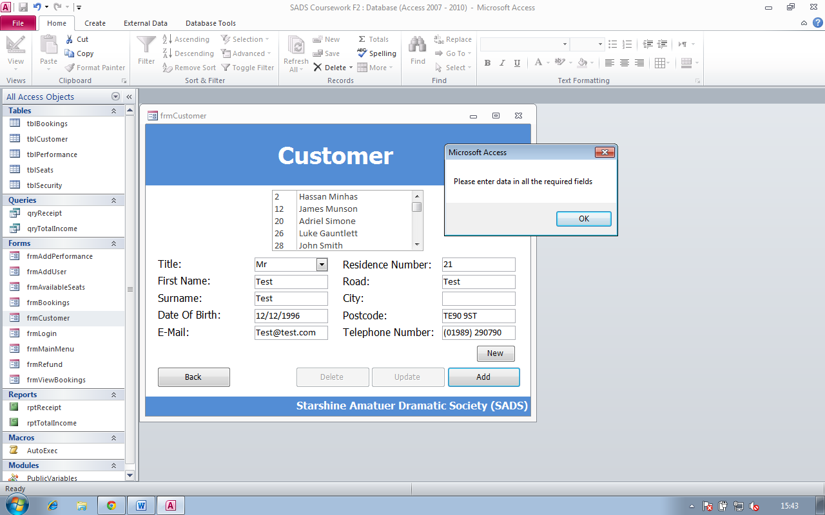

Screenshot 60

Screenshot 59

Here I have missed out the ‘Postcode’ field to show that it is required, as an error message appears if a user would miss out the ‘Postcode’ field

Here I have missed out the ‘City’ field to show that it is required, as an error message appears if a user would miss out the ‘City’ field

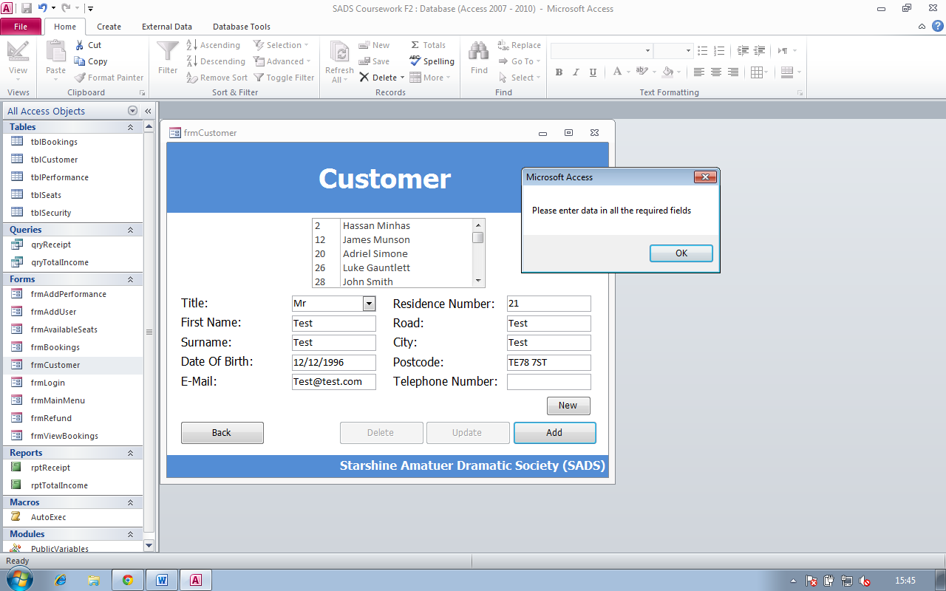

Here I have missed out the ‘Telephone Number’ field to show that it is required, as an error message appears if a user would miss out the ‘Telephone number’ field

Screenshot 61

**Test Number:** 37

**Type of test:** erroneous data test

**Description:** frmBookings

**Screenshot ref:** 62, 63, 64, 65

Screenshot 62

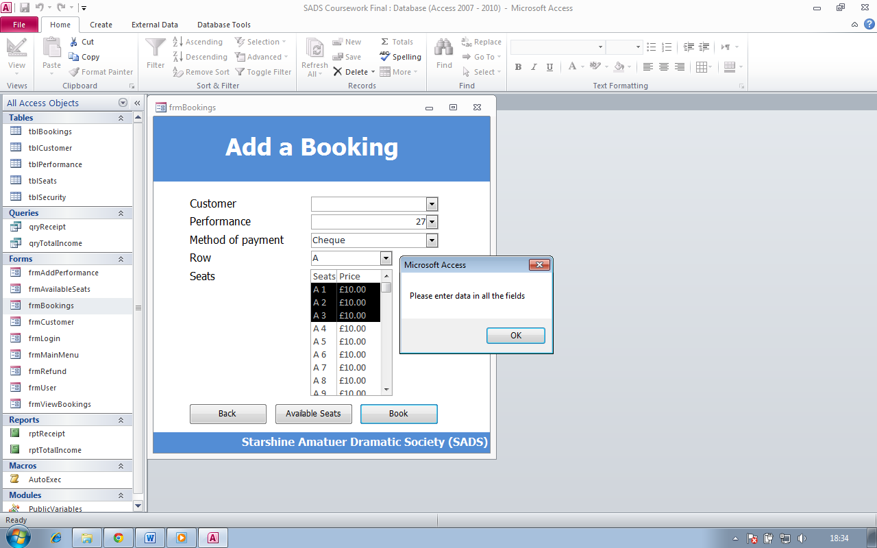

Here I have missed out the ‘Customer ID’ field to show that it is required, as an error message appears if a user would miss out the ‘Customer ID’ field

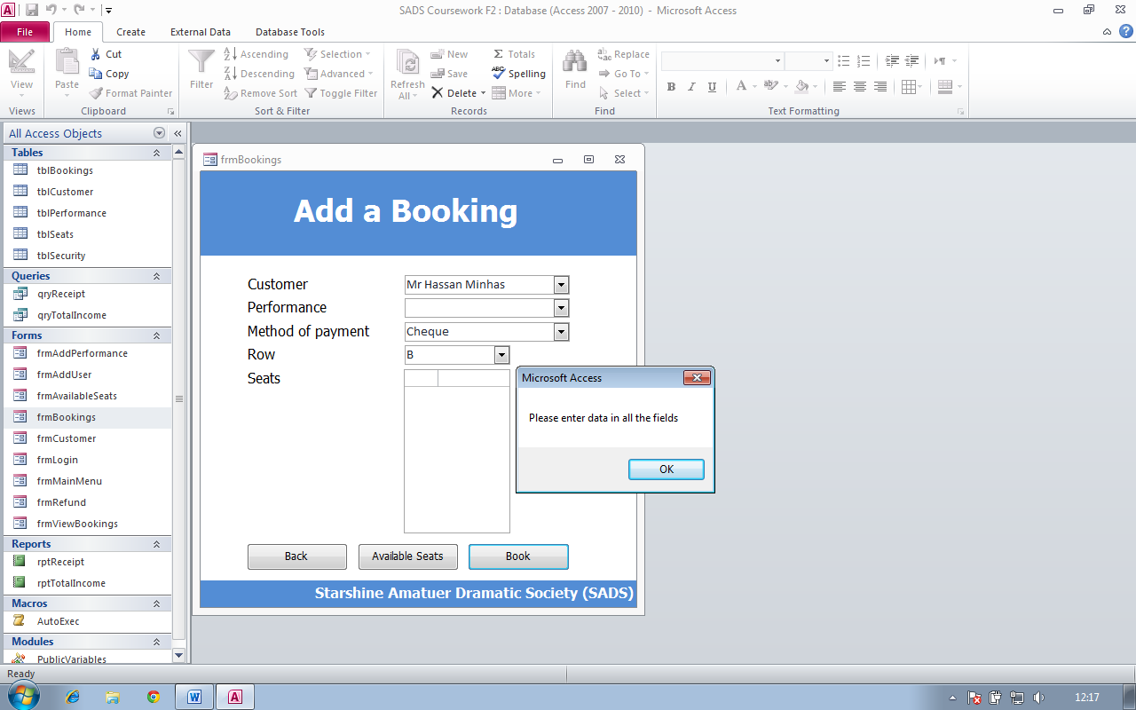

Screenshot 63

Here I have missed out the ‘performance’ field to show that it is required, as an error message appears if a user would miss out the ‘performance’ field. Also the listbox doesn’t have any values as it depends on what performance is selected and if there is no performance selected then you won’t be able to select a seat

Screenshot 64

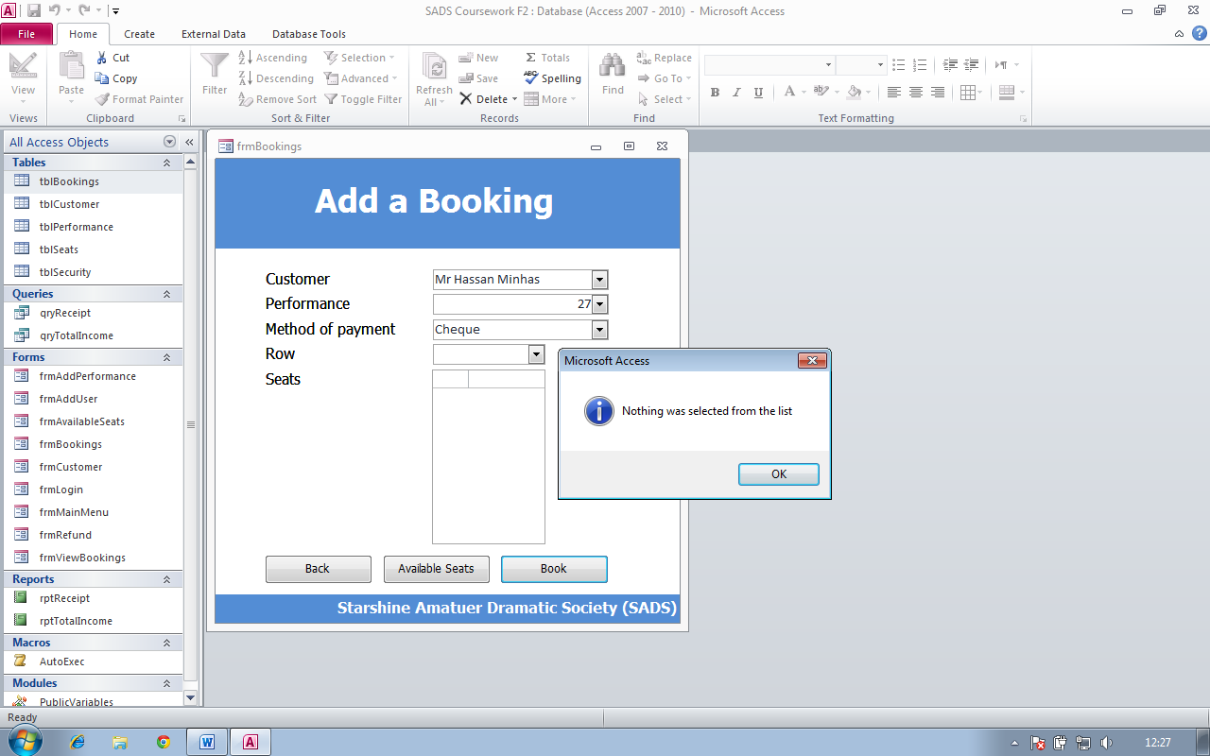

Here I have missed out the ‘row’ field to show that it is required, as an error message appears if a user would miss out the ‘row’ field. Also the listbox doesn’t have any values as it depends on what Row is selected and if there is no row selected then you won’t be able to select a seat

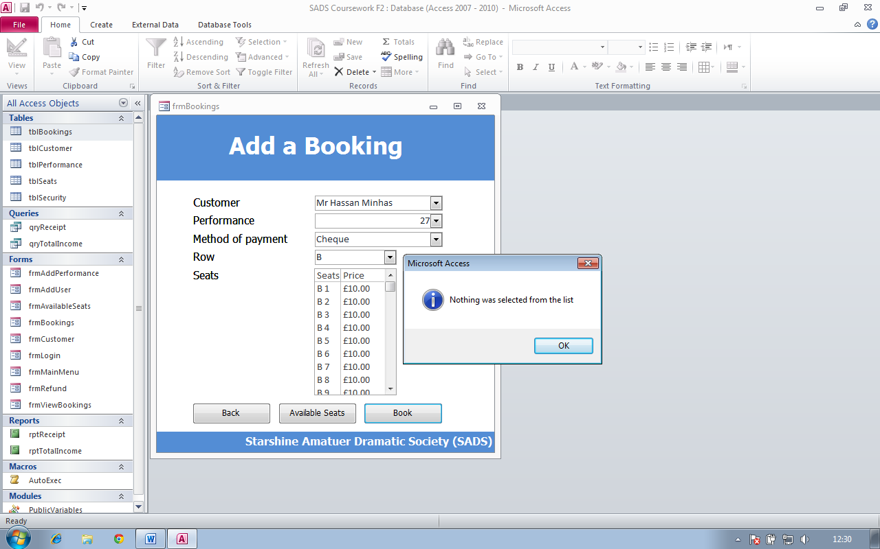

Here I have selected any seats to show that it is required, as an error message appears if a user would not select any seats

Screenshot 65

**Test Number:** 38

**Type of test:** Output tasks

**Description:** Here I will show some of the data output forms

**Screenshot ref:** 66,67

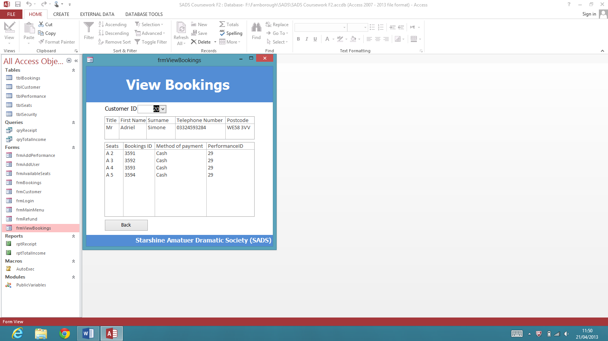

Here I am showing that frmViewBookings shows all the bookings made by a selected customer.

Screenshot 66

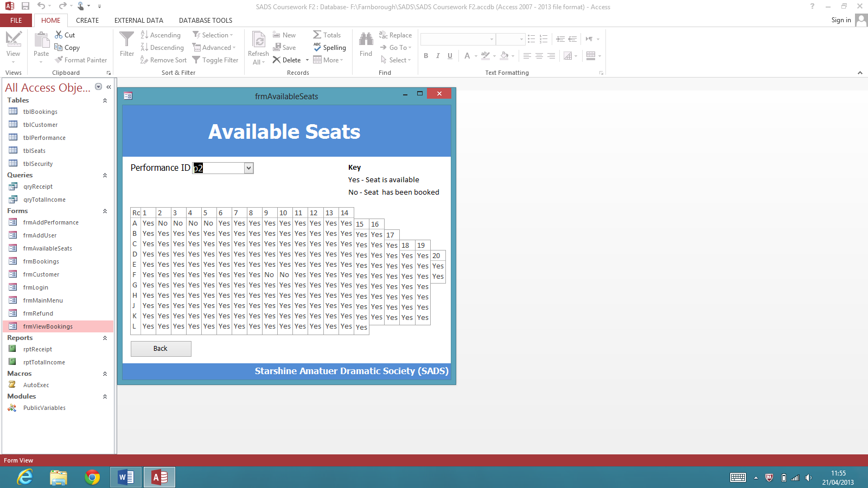

Here I am showing that frmavailableseats shows that whether the seats are available or not for a selected performance

Screenshot 67

**Test Number:** 39

**Type of test:** Security

**Description:** Here I will show some of the elements to my security system

**Screenshot ref:** 68

Screenshot 68

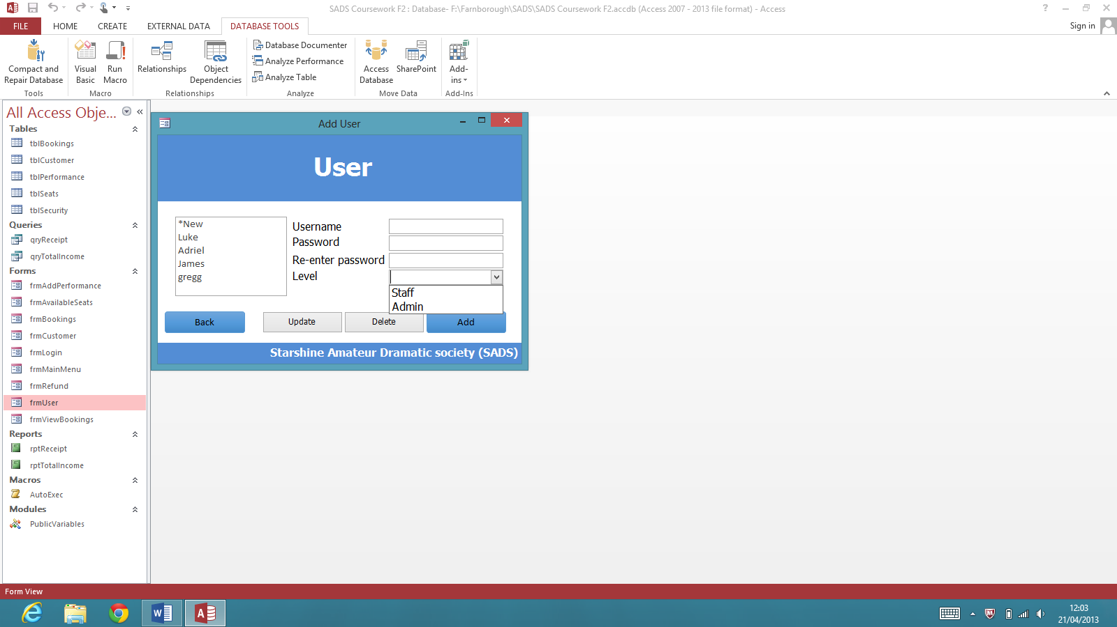

Here I am showing that there are two types of users ‘staff’ and ‘admin’ and the difference between them is that a staff user cannot add a performance or add a user whereas an admin user can add a user or performance. We can also see that a password and username can be set so that the system can determine whether the user is an admin or a staff user.

**Test Number:** 40

**Type of test:** Usability

**Description:** Here I will show some of the elements to the usability of the system

**Screenshot ref:** 69

Screenshot 69

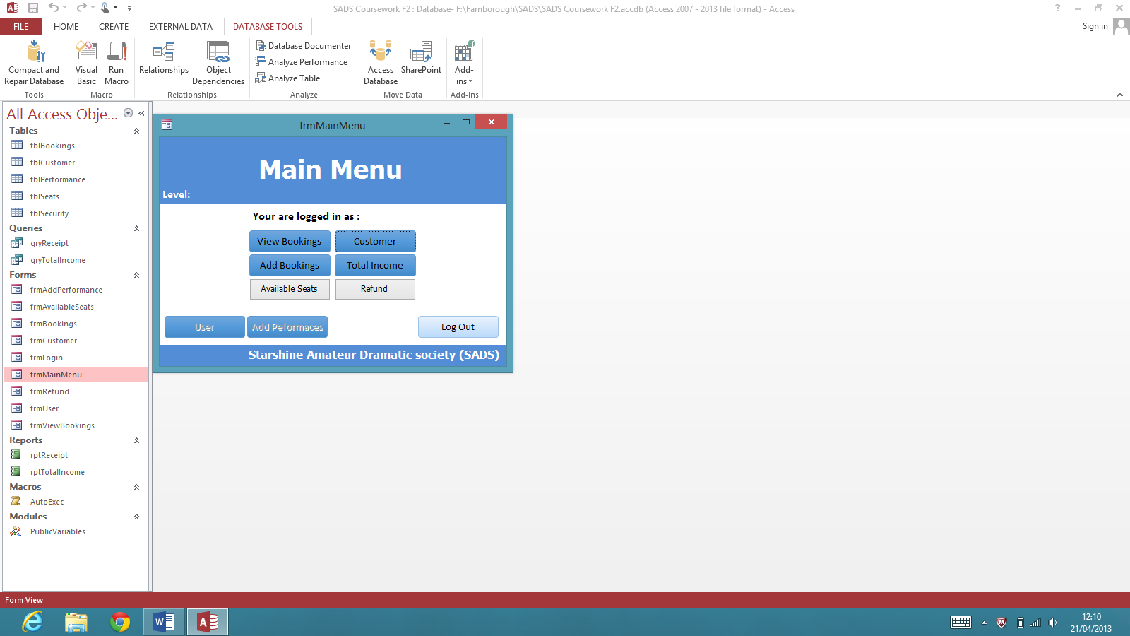

Here I am showing my main menu. As you can see the buttons are laid out quite clearly and they are quite large so that anyone can see them because the user might me old and might have weak eyesight

**Random tests**

Screenshot 70



Here is the code for stopping users from typing in a combo box. Basically what this means that if any character is pressed then don’t allow it to be inputted

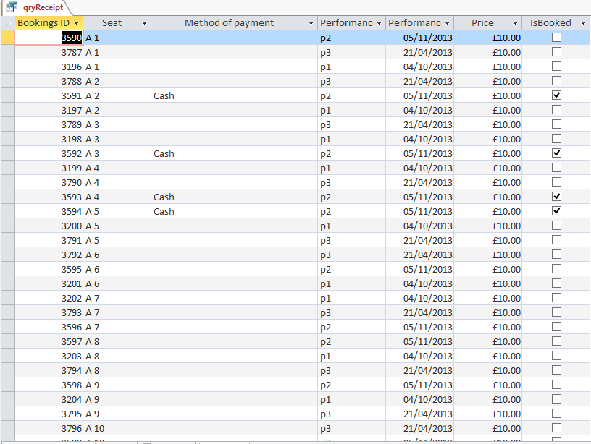

Here is qryReciept. As you can see all the bookings are stored in here and I have used some code to filter this query to only show the seats which have just been booked

Screenshot 71